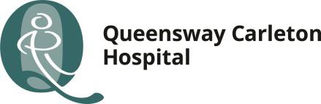

Childbirth Program

COVID-19 Elective Cesarean Section Patient Information
In preparation for your upcoming Cesarean Section (C/S), your care team is encouraging important isolation measures considering the current COVID-19 situation.
At the Queensway Carleton Hospital, we want to make sure that your C/S is completed as safely as possible, and we need your cooperation with the following measures:

Self-isolate to the extent possible for 7 to 14 days before your C/S
- Practice physical distancing (keep 2 meters away from others) as much as possible before your surgery
- Wear a mask if physical distancing will be difficult
- Limit non-essential trips outside of the home
- Work from home, if possible
- Avoid long term care facilities and other care homes

In addition to the above measures, we are recommending that you have a COVID-19 test (swab) done 3 days prior to your scheduled C/S. You can book your COVID test at the QCH COVID-19 Care and Testing Centre on Moodie Drive.

Online booking is available using the following link:

https://www.qch.on.ca/COVIDCareClinic

The goal is to limit your exposure to others outside your home and to situations where you are at an increased risk of contracting the COVID virus. These measures will support that goal.
Please remember, this is for your safety and will also protect your newborn.
We continue to keep your health and safety as our primary concern. Your elective C/S can still be done as safely as it was done before COVID-19, but following these measures is essential to ensure that all necessary precautions have been taken.

