You can help: All about Delirium
What is delirium?
Delirium is a sudden, confused state of mind. It happens more in people who are older, have multiple medical problems, take a lot of medications, have dementia, or have vision or hearing problems. It often occurs when a person is hospitalized, especially if they just had surgery. It is not the same as dementia. There is always a cause for delirium, which is often a medical issue that needs to be treated. Causes include certain medications, a change in environment, dehydration, surgery, or constipation.

What might you see?
- Trouble paying attention
- Sometimes act confused, and other times seem okay
- Become restless and upset
- Have trouble staying awake, sleeping more
- See or hear things that are not there
How can you help?
REMIND | BRING | DISPLAY | TALK
Your loved one of where they are and the date. | Glasses, hearing aids, dentures, and supportive shoes. | Calendars, clocks, family photos, and familiar items. | About family, friends, and familiar topics.
HELP | OFFER | REDUCE | TELL
Your loved one to sit up and walk, and keep active. | Fluids and food and help your loved one eat and drink. | 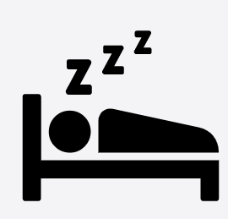  Noise and provide comfort to promote sleep. | Your nurse if your loved one is not their normal self.

- Tell the Health Care team if you notice sudden change in your loved one’s thinking or behaviour.
- If you want more information on other ways you can help, ask your Health Care team for more information. You can also visit: https://ccsmh.ca/projects/delirium/

