PERIOPERATIVE SERVICES
Care of your Surgical Drainage System

Your surgeon has decided to leave your surgical drainage system (drain(s)) in place for a few days after you go home, to continue to remove fluid that would otherwise collet at your surgical site. The surgeon will tell you when to come for drain removal or may arrange for home care to remove the drains.

Your surgical drain is either a Hemovac™ or a Jackson-Pratt™.
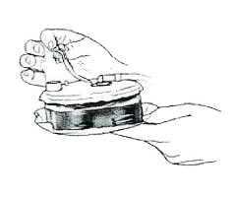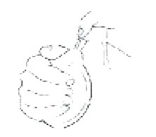

Your nurse will show you how to empty and care for the drain(s) at home.
- Clean the drain closure with an alcohol swab before opening and closing. Empty and measure the drainage system twice a day (more often if needed). You can purchase alcohol swabs and a measuring container at your local Pharmacy.
- If the drain leaks at the site where it leaves the dressing, apply a gauze dressing. A dressing kit can be purchased at the QCH Gift Box.
- Normally over time, the drainage will change colour from clear red to clear pink and then clear yellow. Normally, there is no odour.

How to empty your drains:

Jackson- Pratt™ Drain
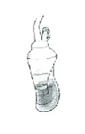  - A Jackson-Pratt™ drain before it has been emptied. It is about the size of a large lemon. | 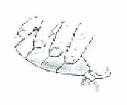  - To empty, open port on bulb shaped reservoir and tilt bulb in direction of port and drain toward opening. Empty drainage fluid into a measuring cup and record the amount of fluid. | 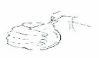  - To re-establish suction, compress the bulb in the palm of your hands with your fingers until the inside walls of the drain touch. While compressing bulb, replace the plug. The drain should remain somewhat flat and not be fully inflated.
Hemovac™ Drain
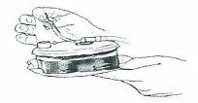  - A Hemovac™ drain before it has been emptied is a round drain with springs inside that must be compressed to establish proper suction. | 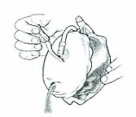  - To empty, remove the plug and empty drain contents into measuring cup and record the amount of fluid. | - To re-establish suction, place suction on flat surface with open outlet facing upward. Continue pressing downward until bottom and top are in contact. And replace plug. The drain should remain somewhat flat and not be full inflated.

Call your surgeon or go to the Emergency Department if you have any of the following:
- Elevated temperature (38ºC or 100.4ºF) and/ or chills lasting more than 24 hours.
- A sudden increase of pain, swelling or tenderness at the surgical site.
- Drainage changes colour dramatically and becomes foul smelling.

