PATIENT CARE SERVICES
Patient Information Sheet
GreenLight Laser™ (GLL)

GreenLightTM Laser therapy of the prostate is a surgery that involves placing a cystoscope (a tube-like camera) that is used to inspect the bladder into the opening at the end of the penis (urethra). The laser is used to remove tissue of the prostate, to the opening so urine can flow more freely. As this surgery is done with a laser no incision made.

Who needs this surgery?
GreenLight TM Laser therapy is use for an enlarged prostate or to treat Benign Prostatic Hyperplasia (BPH), a common condition. A common condition in which the enlarged prostate prevents urine from flowing freely. As the condition worsens pressure on the urethra causes a narrowing.

You may have been experiencing some of the following symptoms of BPH:
- More frequent urination
- A sensation of not emptying your bladder
- A weaker urinary stream

If these symptoms worsen, the urethra may become completely blocked.
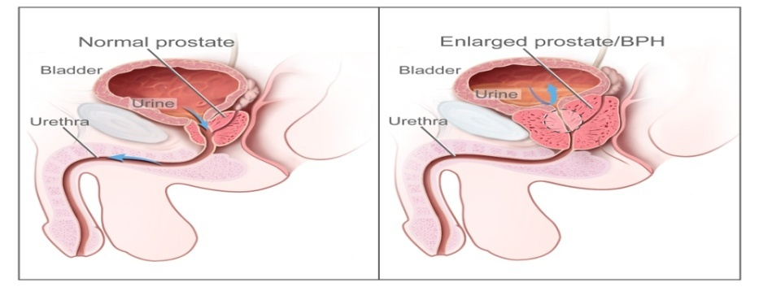
What happens during surgery?
You will have either a spinal or general anaesthetic (as previously discussed with your surgeon). The surgery will take 1-2 hours depending on the size of your prostate. The larger the prostate, the longer the surgery. A cystoscope is put into the opening and directed to the prostate. Once the cystoscope is in place the surgeon can access the prostate and laser the tissue to remove the blockage.
What are the side effects of the surgical procedure?
After the surgery you may experience some of the following symptoms:
- A greater urge to urinate
- More frequent urination
- Blood in the urine is common
- Expect a burning sensation for the first few weeks when you urinate
- To minimize these side effects drink plenty of fluids.

Side effects requiring immediate attention: If you experience any of these side effects: please go to the nearest Emergency Department.
- Unable to urinate-you might need to have a urinary catheter inserted
- Elevated temperature (38ºC or 100.4ºF) and/or chills lasting more than 24 hours
- Increasing pelvic pain or genital pain
- Heavy bleeding that concerns you

Benefits of GLL
GreenLightTM Laser surgery is associated with:
- Earlier discharge from Hospital
- Faster recovery
- Less bleeding during the procedure
- Shorter urinary catheterization time
- Less risk of erectile dysfunction

When will I go home?
Patients usually return home the same day, although some patients need to stay overnight. You must have someone to pick you up after you have recovered from the surgery and your surgeon says that you are ready to go home.

Do I need a urinary catheter? If so, how long does it stay in?
Patients require a urinary catheter to be placed into the opening of the penis to empty the bladder. If you go home with a urinary catheter in place, the nursing staff will give you instructions on how to care for the urinary catheter and when it will be removed.

Are there activities I need to avoid?
Follow these guidelines:
- Rest for 1-2 weeks after surgery to allow your body to heal
- Avoid sexual activity for 6 weeks
- Avoid long car rides for 2 weeks
- Do not lift anything heavy (10 pounds or 4.5 kg) for 4-6 weeks

Do I need to change my diet?
Once you are home you may resume your regular diet. If you are experiencing mild nausea, it is suggested you start with a light meal and fluids first. There are no food or drink restrictions after surgery. You may have been given a prescription for stronger pain medication. A side effect of this medication is constipation. Increase the fibre in your diet and drink plenty of fluids to help prevent constipation. Good sources of fibre are fruits, vegetables and whole grain breads and cereals (All Bran™, Bran Flakes, Shreddies™ and Shredded Wheat). You may also purchase an over the counter stool softener like Colace™ or a mild laxative if needed.

FOLLOW UP:
Your surgeon may schedule your follow up appointment prior to or after your surgery. If you do not hear from the surgeon’s office, please call your surgeon’s office.

FREQUENTLY ASKED QUESTIONS:

How long will the benefits of surgery last?
Some studies suggest that the benefits of surgery last for approximately 5 years. However each individual responds differently.

Do I have to stop taking my blood thinners before surgery?
Speak with your surgeon.

What medications can I expect to take post operatively?
Your doctor will advise you what you can take for pain post operatively. Typical medications include over-the-counter pain relievers as needed. Your surgeon may prescribe antibiotics if necessary.

Will I be awake during the procedure?
Depends on whether you receive a spinal or a general anaesthetic.

Is Benign Prostatic Hyperplasia (BPH) cancer?
No, it is not cancer. BPH is a benign enlargement of the prostate gland.

How soon will I see results?
Relief of symptoms should occur within a few days to a few weeks.

NOTES:
____________________________________________________________________________________________________________________________________________________________________________________________________________________________________________________________________________________________________________________________________________________________________________________________________________________________________________________________________________________________

The information contained on this sheet is provided to you and your family to help you in your recovery from this procedure. This document is not intended to replace medical advice from your doctor or healthcare team. If you require more specific/additional medical advice, contact your doctor and healthcare team about your particular healthcare needs.

Protect yourself! Clean your hands frequently using soap and water or hand sanitizer, and ask that your healthcare providers and visitors do the same." Clean hands save lives.

