Day Surgery

Patient Information Booklet

Pre-Operative

Assessment Clinic

Please bring this book to your admission to the Hospital and to all of your appointments

For Information Call

613-721-2000 extension 2920

Between 8:00 a.m. and 4:00 p.m.

Monday to Friday

**Your date of surgery is: ____________________________________________**

The day before surgery, call the Queensway Carleton Hospital, Operating Room Scheduling Department at **613-721-4840** **between 11:00 a.m. and 3:00 p.m.** to have your admission time confirmed.

Preparing for your surgery

You must follow these rules if you are to have your surgery on the scheduled date:

* DO NOT EAT ANY SOLID FOOD AFTER MIDNIGHT THE NIGHT BEFORE YOUR SURGERY OR YOUR SURGERY WILL BE CANCELLED.
* You should drink one cup (250 mLs) 8 ounces clear fluid e.g. apple juice, water or ginger-ale™, before leaving to come to hospital.

You should take your regular prescription medications with water the morning of surgery. **If you use any inhalers bring them with you. Bring your medications with you to the Hospital.**

You may also be asked to stop taking medications such as Vitamin E, ginkgo biloba, omega, garlic or ginseng at least one week before surgery. These medications “thin” your blood, which could cause excessive bleeding during and after surgery. Check with your Surgeon.

Other pre-operative instructions:

_____________________________________________

_______________________

_______________________

_______________________

**On the day of your Pre-Operative Assessment Clinic visit we advise you to purchase 2 scrub brushes of Chlorhexidine soap. They can be purchased at the QCH Gift Box on the main floor next to the front lobby.**

Gift Shop Hours

Monday to Friday 9 a.m. to 4 p.m. and 5 p.m. to 8 p.m.

Weekends 12 p.m. to 4 p.m.

Image of body with shaded area showing areas to cleanSkin preparation

Stop shaving in the operative area one week (7 days) before your surgery date. Shaving can cause tiny nicks in the skin that may allow germs to enter your body and cause an infection. **Do not use bath scents, powders or body lotions.**

* The night before surgery bath or shower and wash your entire body using the Chlorhexidine soap.
* The morning of surgery repeat your bath or shower using the Chlorhexidine soap sponges.
* If you are a smoker, stop smoking 24 hours before your surgery. We can provide you with smoking cessation support to prevent nicotine withdrawal during your hospitalization.
* The day of surgery **do not** wear cosmetics, make-up, nail polish, contact lenses and any jewellery. **DO NOT wear any scented products, aftershave, cologne, perfume and deodorant, as many of our staff/patients experience severe reaction to these products.**
* Please bring your Ontario Health Card with you.
* **Do not** bring valuables (i.e. jewellery, credit cards, money) to the Hospital. **WE DO NOT ASSUME RESPONSIBILITY FOR ANY LOST OR STOLEN ARTICLES.**
* **Do not** drive your car to the Hospital the day of surgery. You must arrange for a responsible person who can drive or accompany you home after discharge. **Your drive must be available throughout the day of your surgery.**

Please indicate the name and phone number of the person taking you home below:

**Name: _____________________________________________**

**Home phone #: ______________________________________**

**Work phone #: ______________________________________**

**Cell phone #: _______________________________________**

**NOTE: If you develop a cold or other illness, notify your Surgeon before your operation.**

Jewelry and body piercing removal prior to surgery

It is the recommendation of the Queensway Carleton Hospital that **all jewelry, including body piercing and wedding rings,** be removed prior to surgery.

The known risks of leaving in jewelry or body piercing in place during surgery may include:

* Injury from a burn if the electro-surgical unit is used during surgery.
* An increased risk of infection if the jewellery is near the surgery site. Jewellery harbours bacteria.
* Possible restrictions of blood flow by the jewellery/body piercing from tissue swelling near the surgical site following surgery.
* An increased risk of injury at the jewellery/body piercing if the jewellery or body piercing becomes tangled in the patient gown or sheets during positioning for surgery or when being transferred to the stretcher after the surgical procedure.
* An increased risk of injury during anesthetic if the body piercing is in the nose, tongue or mouth (these MUST be removed).

Body piercing can be removed by the “body piercing store”.

If you choose to accept these risks and arrive for your surgical procedure with the jewelry or body piercing in place, there is a possibility that your surgery will be cancelled by the Anesthesiologist or Surgeon depending on the location of the jewelry/body piercing.

If you choose to accept these risks and decide to keep your jewelry/body piercing for the procedure and the surgery proceeds, it will be documented on your chart that you were aware of the risks and that you will assume the responsibility for any negative outcome.

Arrival at Hospital

Report to Patient Registration on the main floor. Bring your Ontario Health Card with you.

* From Patient Registration, you will be taken to the Day Surgery Unit (DSU).
* You may be accompanied to the Day Surgery Unit (DSU) by one care partner/family member who may remain with you until you go to surgery.
* You will be required to change into a hospital gown.
* A Nurse will complete your preparation for surgery.
* You will talk to your Anesthesiologist about types of anesthesia for your procedure and your Surgeon in the Day Surgery Unit (DSU). The Nurse, Anesthesia Assistant or Anesthesiologist will start an intravenous by inserting a small needle into your arm or hand.
* An Operating Room Nurse or Ward Assistant will accompany you to the Operating Room.

After surgery

* After your surgery, you will go to the Post Anesthetic Care Unit (PACU) for monitoring.
* The Nurse will check your blood pressure, pulse and operative site frequently.
* You will have an intravenous (IV).
* You may have an oxygen mask on temporarily.
* If you feel any pain or nausea, inform the Nurse. You will be given medication to help this.
* You will be transferred to the Day Surgery Unit (DSU) when the Nurse determines it is safe to move you.
* You should have one designated care partner/family member stay at your bedside in the Day Surgery Unit (DSU). You and your care partner will receive your post operative instructions together for your discharge preparation.
* If your care partner has not remained at the hospital, they will be notified when you are ready for discharge.
* The Day Surgery Nurse will give you all your post-operative instructions before you leave the Hospital.
* A Day Surgery Nurse may call you the day after your surgery.

Leg exercises

You may be drowsy after the surgery. As you become more alert, we will encourage you to exercise. **The following leg exercises will help to prevent complications.**

Point your toes towards your head, then towards the foot of the bed. Make your feet go around in circles 5 times.

**This is done 4-5 times a day until you are walking.**

Deep breathing and coughing exercises

Take a deep breath in through your nose and blow out through your mouth. Repeat this 3 times. On the third breath, cough 2 to 3 times.

**This is done every 2 hours for the first day and then every 4 hours for the next 1-2 days.**

GENERAL POST-OPERATIVE INSTRUCTIONS

We want your recovery to be safe and as comfortable as possible. For this reason, we suggest that you comply with the following advice:

* You should have someone with you for the first few hours upon returning home.
* You must not drive a car or operate machinery for at least 24 hours after the procedure.
* You should limit activity requiring full concentration: e.g. making important personal or business decisions, as full mental alertness may not return for several hours.
* You should not drink any alcoholic beverages for at least 24 hours following your procedure as alcohol may influence the effects of the drugs you have been given.
* You should eat lightly for the first meal following your procedure.
* You should take it “easy” for a day or two.
* If you have any problems or are concerned about your condition for any reason, please contact your Surgeon through his/her office or follow the directions on your Surgeon’s message machine regarding reaching another Surgeon.
* If you are unable to contact your Surgeon or the Surgeon covering his/her practice, come to the Emergency Department of the hospital where you will be seen by an Emergency Physician.

Return appointment reminder

DATE: ____________________________

TIME: ____________________________

LOCATION:  QCH Admitting Department

Doctor’s office

Other: ________________________________

YOUR DRIVE HOME **MUST** BE AVAILABLE FOR THE ENTIRE DAY OF YOUR SURGERY

**Please give these instructions to your designated driver.**

Please remind your designated driver they are to be available for the entire day of your surgery and to ensure they keep their phone on and ready to receive the call from the Day Surgery Unit (DSU informing them of the time to pick you up.

Pick up information

The care partner/family members are encouraged to remain at the hospital. If partner/family are not able to stay, please ensure that they are within 10 minutes of the hospital.

For those who cannot remain and are collecting a patient, please drive to the James Beach Health Care Centre entrance door. Inside the building there is a wall mounted telephone on the right-hand side with the phone number to the Day Surgery Unit (DSU) posted.

Please pick up the phone and dial 2912 to let them know you have arrived. You may then return to your car.

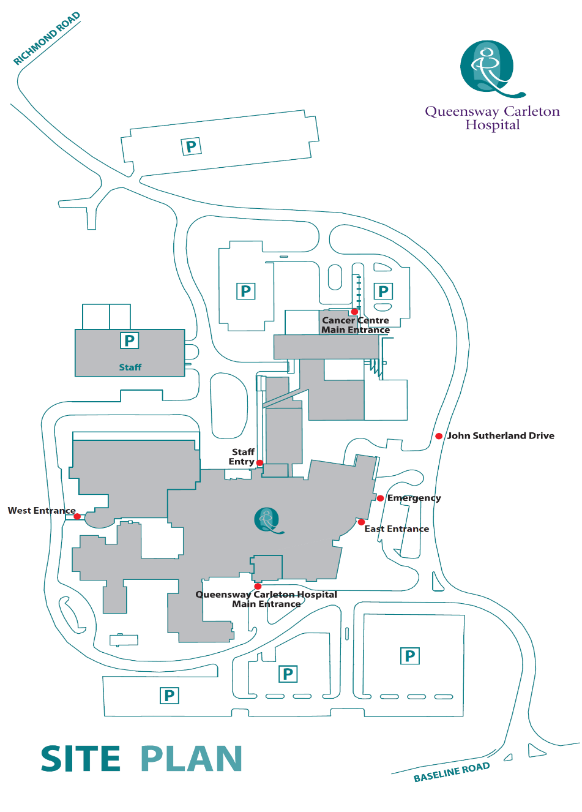

**James Beach Health Care West Entrance (patient pickup)**

**Main Entrance** **(patient drop off)**

Post-operative dressing

* If you are a Day Surgery patient, you will probably need some sterile dressings and tape at home after your surgery.
* We advise you to purchase these supplies before your surgery.
* We suggest that you get a small package of sterile 4” X 4” gauze pads and a roll of tape at the drugstore before your surgery.
* If you are having a gynecological procedure, you should buy some sanitary pads for when you return home.
* Other: _______________________________________________________

If you have any questions about the dressing type to purchase, please check with your Nurse in the Pre-Operative Assessment Clinic (POAC).

Pain scale ruler

What is a pain scale ruler?

A pain scale ruler is a simple tool to measure how much pain you are having. Each Nurse will use this ruler to measure your pain.

Why do we measure your pain?

We measure your pain frequently so that we can be sure your pain medication is working.

What does a pain scale ruler look like?

One side of the ruler has numbers from 1 to 10. The other side has colors from white to deep red (shown here in shades of grey).

How does our pain scale ruler work?

Our ruler measures pain in two ways – by number or colour.

**By number:** the ruler is numbered from 0 to 10, with 0 being no pain and 10 being the most severe pain you can imagine.

**By faces:** the faces are coloured and range from happy, with 0 being no pain as shown with a clear face to sad with 10 being the most severe pain you can imagine as shown with a deep red face. (Shown in this example as shades of grey).

The Nurse will show you the ruler and ask you to choose a number or colour.

