**Arthroscopic Knee Surgery**

**Patient Information Booklet**

**Please bring this book to your admission to the Hospital and to all of your appointments**

For information call

613-721-2000, extension 2920

between 8:00 a.m. and 4:00 p.m.

Monday to Friday

Table of Contents

Introduction 3

Your physiotherapy rehabilitation restrictions are: 4

Preparing for your surgery 5

Arrival at Hospital 7

After surgery 7

Leg exercises 8

Deep breathing and coughing exercises 8

General post-operative instructions 8

Pick up information 10

Post-operative dressing 11

Pain scale ruler 12

Activity 12

Follow up 13

Additional information 13

Post-operative exercises 14

Initial Exercise Program 14

Advanced Exercise Program 18

## 

# Introduction

Welcome to Queensway Carleton Hospital.

You are having an outpatient day surgery procedure. The plan is for you to be discharged home on the same day as your surgery.

Please use this booklet as a reference tool. Bring this booklet with you to all your appointments and on your day of surgery. Ask questions if there is anything you don’t understand.

**PLEASE BRING YOUR BOOKLET TO THE HOSPITAL** as the healthcare team members will refer to these instructions throughout your hospital stay.

This sheet will provide information about your surgery to your physiotherapist and/or doctor. Your surgeon will complete the information below in a separate handout. A copy will be provided to you, please keep this copy for your records.

Surgery date:

Your surgery is:

🞎 **Knee Arthroscopy**

🞎 Partial meniscectomy Medial Lateral

🞎 Meniscus repair

For Meniscus repair only - *No running, no jumping, no impact activity, no deep squats for 4 months

🞎 **Debridement (chondropathy grade)**

* Medial ( )
* Lateral ( )
* Patello-femoral ( )

🞎 Excision of loose body

🞎 Excision of plica

🞎 Lateral release

🞎 Medical patellofemoral repair/plication

🞎 **Other**

## Your physiotherapy rehabilitation restrictions are:

**🞎 Weight bearing**

🞎 Full

🞎 Partial for then progress to

🞎 None for then progress to

**🞎 Motion**

🞎 No restrictions

🞎 No range of motion (ROM) for then

🞎 0–45 degrees for then

🞎 0–60 degrees for then

🞎 0–90 degrees for then

**🞎 Strengthening**

🞎 No restrictions

🞎 As tolerated

🞎 None

**🞎 Modalities**

🞎 As tolerated

🞎 None

**🞎 Resume full activity / running / sports**

🞎 When there is no pain with day to day activity

🞎 Swelling is gone

🞎 Knee is bending and straightening fully

🞎 Not until specified by your surgeon

For Meniscus repair only - *No running, no jumping, no impact activity, no deep squats for 4 months.

**🞎 Comments:**

**Your date of surgery is:**

The day before surgery, call the Queensway Carleton Hospital, Patient Scheduling Department at **613-721-4840** **between 11:00 a.m. and 3:00 p.m.** to have your admission time confirmed.

## Preparing for your surgery

You must follow these rules or your surgery may be cancelled:

1. **Do not eat any solid food after midnight the night before your surgery**
2. **If you are thirsty, you may drink clear fluids apple juice, water or ginger-ale™ until you leave to come to the hospital**
3. **Please drink one cup (250 mLs or 8 oz) clear fluid either apple juice, water or ginger-ale™, before leaving to come to hospital**

You should take your regular prescription medications (no vitamins or herbal products) with water the morning of surgery as advised by the nurse or doctor you spoke with in POAC. **Bring your medications including any inhalers with you to the Hospital.**

You **must** stoptaking all supplements **except** vitamin D, calcium, or iron/iron supplements one week before surgery.

If you are taking Aspirin or other blood thinners, please inform your surgeon or nurse. You will be given specific instructions.

Other pre-operative instructions:

**On the day of your Pre Op Assessment Clinic we advise you to purchase 2 scrub brushes of Chlorhexidine soap. They can be purchased at the QCH Gift Box on the main floor next to the front lobby.**

Gift Box Hours

Monday to Friday 9 a.m. to 8 p.m.

Weekends 12 p.m. to 4 p.m.

* **Skin preparation:**  Stop shaving in the operative area one week (7 days) before your surgery date. Shaving can cause tiny nicks in the skin that may allow germs to enter your body and cause an infection. **Do not use bath scents, powders or body lotions.**

Skin preparation:

1. The night before surgery bath or shower and wash your entire body using the Chlorhexidine soap. Pat yourself dry with a fresh clean soft towel, put on clean pajamas or clothes and put on freshly laundered bed linens if you are able

**Body shaded from the neck down**

1. The morning of surgery repeat your bath or shower using the Chlorhexidine 4% soap sponges.

**(Chlorhexidine 4% soap sponges are available at the QCH Gift Box)**

* If you are a smoker, stop smoking 24 hours before your surgery. We can provide you with smoking cessation support to prevent nicotine withdrawal during your hospitalization.
* On the day of surgery **do not** wear make-up, any jewelry, body piercings, nail polish, deodorant or contact lenses. If you are unable to remove rings from operative site, you must have them removed by a jewelry. Remove body piercing and replace with plastic plugs.
* QCH is scent-free. **Please do not wear any scented products to the hospital.**
* Please bring your Ontario Health Card with you.
* **Do not** bring valuables (i.e. jewellery, credit cards, money) to the Hospital. **WE DO NOT ASSUME RESPONSIBILITY FOR ANY LOST OR STOLEN ARTICLES.**
* **Do not** drive your car to the Hospital the day of surgery. You must arrange for a responsible person who can drive or accompany you home after discharge. **Your drive must be available throughout the day of your surgery.**

Please indicate the name and phone number of the person taking you home below:

**Name**:

**Home phone #:**

**Work phone #:**

**Cell phone #**:

**NOTE: If you develop a cold or other illness, notify your Surgeon before your operation.**

# Arrival at Hospital

Report to Patient Registration on the main floor. Bring your Ontario Health Card with you.

* From Patient Registration, you will be taken to the Day Surgery Unit.
* You may be accompanied to the Day Surgery Unit by one care partner/family member who may remain with you until you go to surgery.
* You will be required to change into a hospital gown.
* A nurse will complete your preparation for surgery.
* You will talk to your anesthesiologist about types of anesthesia for your procedure and your surgeon in the Day Surgery Unit. The nurse, anesthesia assistant or anesthesiologist will start an intravenous by inserting a small needle into your arm or hand.
* An Operating Room nurse or patient care assistant will accompany you to the Operating Room**.**

# After surgery

* After your surgery, you will go to the Recovery Room for monitoring.
* The nurse will check your blood pressure, pulse and operative site frequently.
* You will have an intravenous (IV).
* You may have an oxygen mask on temporarily.
* If you feel any pain or nausea, inform the nurse. You will be given medication to help this.
* You will be transferred to the Day Surgery Unit when the nurse determines it is safe to move you.
* You should have one designated care partner/family member stay at your bedside in the Day Surgery Unit. You and your care partner will receive your post-operative instructions together for your discharge preparation.
* If your care partner has not remained at the hospital, they will be notified when you are ready for discharge.
* The Day Surgery nurse will give you all your post-operative instructions before you leave the Hospital.
* A Day Surgery nurse may call you the day after your surgery.

## Leg exercises

You may be drowsy after the surgery, as you become more alert we will encourage you to exercise. **The following leg exercises will help to prevent complications.**

Point your toes towards your head, then towards the foot of the bed. Make your feet go around in circles 5 times.

**This is done 4-5 times a day until you are walking.**

## Deep breathing and coughing exercises

Take a deep breath in through your nose and blow out through your mouth. Repeat this 3 times. On the third breath, cough 2 to 3 times.

**This is done every 2 hours for the first day and then every 4 hours for the next 1-2 days.**

# General post-operative instructions

**(Day Surgery patients)**

We want your recovery to be safe and as comfortable as possible. For this reason, we suggest that you comply with the following advice:

* You should have someone available to stay with you overnight upon returning home.
* Your surgeon will instruct you as to when you can drive a car or operate machinery but in the absence of such instructions, not for at least 24 hours after the procedure.
* You should limit activity requiring full concentration for 24 hours; e.g. making important personal or business decisions, as full mental alertness may not return for several hours.
* You should not drink any alcoholic beverages for at least 24 hours following your procedure as alcohol may influence the effects of the drugs you have been given.
* You should eat lightly for the first meal following your procedure.
* You should take it “easy” for a day or two.
* If you have any problems or are concerned about your condition for any reason, please contact your surgeon through his/her office or follow the directions on your surgeon’s message machine regarding reaching another surgeon.
* If you are unable to contact your surgeon or the surgeon covering his/her practice, come to the Emergency Department of the hospital where you will be seen by an emergency physician.

Deep Vein Thrombosis (DVT) is a blood clot in a deep vein and is a major health concern that should be discussed with your physician.

You may be at risk for developing a DVT for any of the following reasons:

* Recent surgery
* Immobility
* Previous DVT
* Problems with circulation
* Obesity
* Increasing age
* Acute medical illness

DVT’s most commonly occur in the legs, usually the calf. Signs and symptoms to watch for include: calf pain or swelling, redness or discolouration, a knot in the calf that you can feel and that is warm to touch, fever, shortness of breath, rapid heart rate or chest pain.

If you experience any of these symptoms go to the Emergency Department or call 911 for immediate assistance.

**Return appointment reminder**

DATE:

TIME:

LOCATION: □ QCH Admitting Department

□ Doctor’s office

□ Other:

YOUR DRIVE HOME ***MUST*** BE AVAILABLE FOR THE ENTIRE DAY OF YOUR SURGERY

**Please give these instructions to your designated driver.**

Please remind your designated driver they are to be available for the entire day of your surgery and to ensure they keep their phone on and ready to receive the call from the Day Surgery Unit informing them of the time to pick you up.

## Pick up information

The care partner/family members are encouraged to remain at the hospital.

Inside the James Beach Health Care Centre entrance door is a wall mounted telephone on the right hand side with the phone number to the Day Surgery Unit. Please pick up the phone and dial 2912 to let them know you have arrived. You may then return to your car.

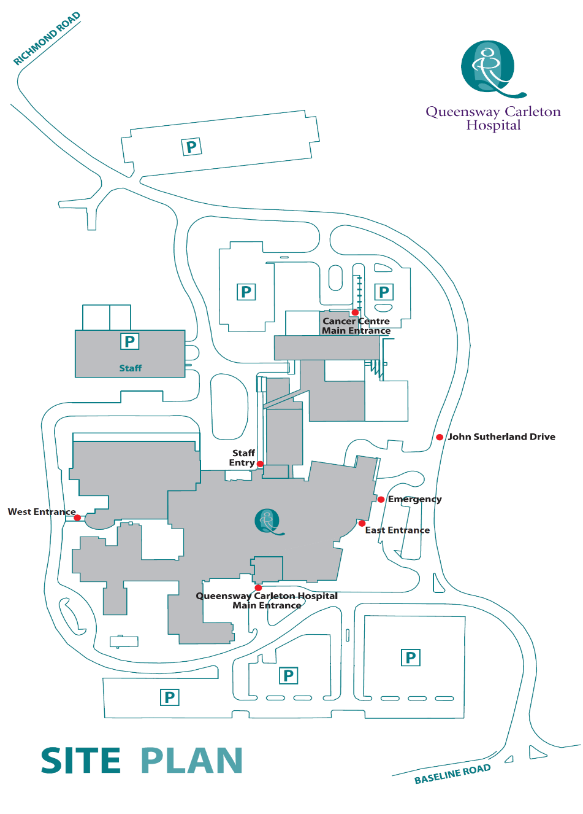

**James Beach Health Care West Entrance (patient pickup)**

**Main Entrance** **(patient drop off)**

## Post-operative dressing

If you are a Day Surgery patient, you will probably need some sterile dressings and tape at home after your surgery.

1. We advise you to purchase these supplies before your surgery.
2. We suggest that you get a small package of sterile 4” X 4” gauze pads and a roll of tape at the drugstore before your surgery.
3. Other:

If you have any questions about the dressing type to purchase, please check with your nurse in the Pre-Operative Assessment Clinic.

## Pain scale ruler

Your nurse will ask you to rate your pain on either the number or FACES scale (see below). Pain is rated from 0 (no pain) to 10 (worst pain).

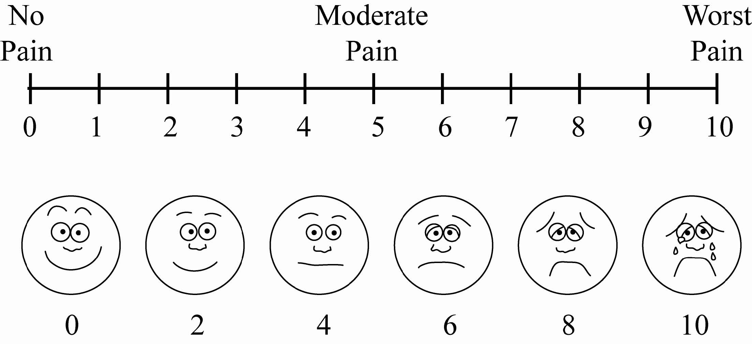

**Pain**

Upon discharge, you will be given a prescription for pain medication(s). Please take the pain medication with food and as directed. Elevate the leg and apply ice pack or cold gel pack regularly (keeping dressing dry). **Do not drink alcoholic beverages or drive if you are using pain medications.**

**Operative site**

A dressing has been applied to your incision which consists of tensor bandage, gauze, and skin tapes next to the skin itself. Keep the dressing dry. You may shower 4 days after your surgery, during which the outer dressing may be removed. Do not remove the tapes on the skin. Rewrap the tensor bandage snugly after showering.

Follow the activity directions belowUNLESS OTHERWISE SPECIFIED BY YOUR SURGEON:

## Activity

Put as much weight on the leg as is comfortable **unless** otherwise specified by your surgeon.

Additional activity information:

* Crutches are for comfort only. Stop using them as soon as you are comfortable walking without them **unless** specified otherwise by your surgeon
* Gently bend and straighten the knee as often as possible
* Gentle stationary biking (low resistance) is a good way to rehabilitate your knee
* Avoid high impact activity (jogging) until allowed by your surgeon
* Other:

Restrict yourself to a light diet as tolerated on the day of your surgery. The next day resume your normal diet as tolerated with extra fiber and fluids as pain medications have a tendency to cause constipation.

## Follow up

Your follow-up appointment will be made approximately one to two weeks after your surgery. Physiotherapy may be started prior to your appointment depending on swelling, pain, and surgery performed. Your surgeon will advise you regarding physiotherapy.

## Additional information

Call your surgeon immediately or go to the nearest Emergency Department if you have any of the following:

* Excessive drainage through your bandage
* Severe pain not relieved with your pain medication
* Signs and symptoms of infection
* the incision is red
* the knee is hot and swollen
* yellow/green or foul-smelling discharge from the incision
* Elevated temperature (38ºC or 100.4ºF) and/or chills lasting more than 24 hours
* Sudden shortness of breath, rapid heart rate or chest pain/chest discomfort.
* Increased calf or leg pain, soreness or tenderness and/or swelling
* Unusual dizziness or light headedness.

Notes:

# Post-operative exercises

## Initial Exercise Program

**Hamstring Contraction**

No movement should occur in this exercise. Lie or sit with your knees bent to about 10 degrees. Push your heels into the floor, tightening the muscles on the back of your thigh. Hold for 5 seconds, then relax.

Repeat 10 times.

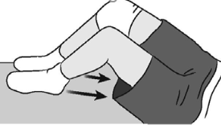

**Quadriceps Contraction**

Lie on stomach with a towel roll under the ankle of your involved knee. Push ankle down into the towel roll and try to lift your knee off the bed. Your leg should straighten as much as possible. Hold for 5 seconds, then relax.

Repeat 10 times.

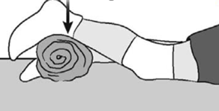

**Buttock Tucks**

While lying down on your back, tighten your buttock muscles. Hold tightly for 5 seconds, then relax.

Repeat 10 times.

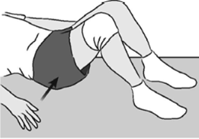

**Straight Leg Raises, Standing**

Support yourself, if necessary, and slowly lift your involved leg forward keeping your knee straight. Return to the starting position.

Repeat 10 times.

Advanced: Before starting, add weights to your ankle, starting with 1 pound of weight and building up to a maximum of 5 pounds of weight over 4 weeks.

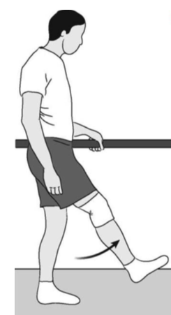

***Terminal Knee Extension, Supine***

Lie on your back with a towel roll under your knee.

Straighten your knee (while keeping the back of your knee touching the roll) and hold for 5 seconds. Slowly return your foot to rest on the bed.

Repeat 10 times.

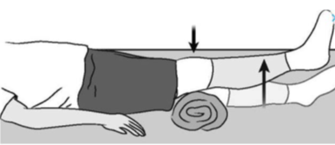

Advanced: Before starting, add weights to your ankle, starting with 1 pound of weight and building up to a maximum of 5 pounds of weight over 4 weeks.

**Straight Leg Raises**

Lie on your back, with your uninvolved knee bent. Straighten your other knee with a quadriceps muscle contraction.

Now, slowly raise your leg until your foot is about 8 inches from the floor. Slowly lower it to the floor and relax.

Perform 5 sets of 10 repetitions.

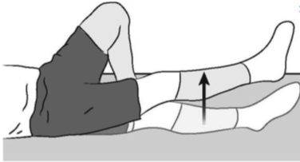

Advanced: Before starting, add weights to your ankle, starting with 1 pound of weight and building up to a maximum of 5 pounds of weight over 4 weeks.

**Partial Squat, with Chair**

Hold onto a sturdy chair or counter with your feet 6-12 inches from the chair or counter. While keeping your back straight, slowly bend your knees. DO NOT go any lower than 90 degrees. Hold for 5-10 seconds. Slowly come back up. Relax.

Repeat 10 times.

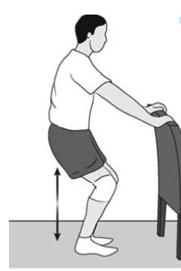

**Quadriceps Stretch, Standing**

Standing with your involved knee bent, gently pull heel toward buttocks, feeling a stretch in the front of the leg. Hold for 5 seconds.

Repeat 10 times.

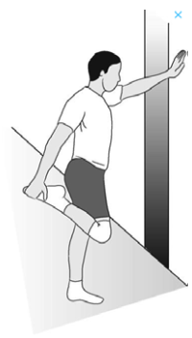

**Post-operative exercises**

## Advanced Exercise Program

**Knee Bend, Partial, Single Leg**

Stand supporting yourself with the back of a chair. Bend your uninvolved leg with your toe touching for balance as necessary. Slowly lower yourself, keeping your foot flat. Do not overdo this exercise. Straighten up to the starting position. Relax.

Repeat 10 times.

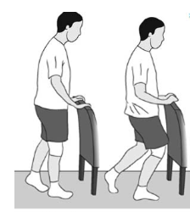

**Step-ups, Forward**

Step forward up onto a 6-inch high footstool or platform, leading with your involved leg. Step down, returning to the starting position. Increase the height of the platform as strength increases.

Repeat 10 times.

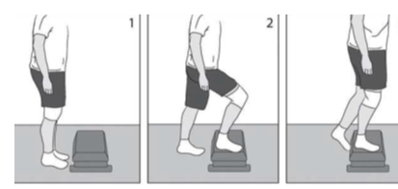

**Step-ups, Lateral**

Step up onto a 6-inch high footstool or platform, leading with your involved leg. Step down, returning to the starting position. Increase the height of the platform as strength increases.

Repeat 10 times.

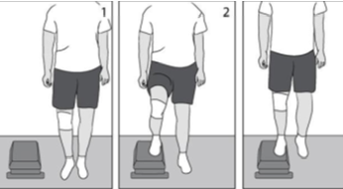

**Terminal Knee Extension, Sitting**

While sitting in a chair, support your involved heel on a stool. Now straighten your knee, hold for 5 seconds and then slowly return to the starting position.

Repeat 10 times.

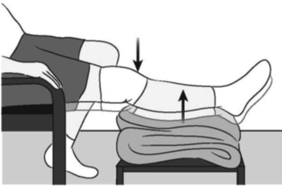

**Hamstring Stretch, Supine**

Lie on your back. Bend your hip, grasping your thigh just above the knee. Slowly straighten your knee until you feel the tightness behind your knee. Hold for 5 seconds, then relax.

Repeat 10 times.

Repeat with the other leg.

If you do not feel this stretch, bend your hip a little more, and repeat.

No bouncing! Maintain a steady, prolonged stretch for the maximum benefit.

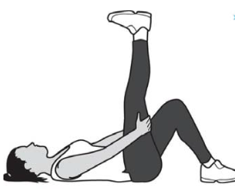

**Hamstring Stretch, Supine at Wall**

Lie next to a doorway with one leg extended. Place your heel against the wall. The closer you are to the wall, the more intense the stretch.

With your knee bent, move your hips toward the wall. Now begin to straighten your knee. When you feel the tightness behind your knee, hold for 5 seconds and then relax.

Repeat 10 times.

Repeat with the other leg.

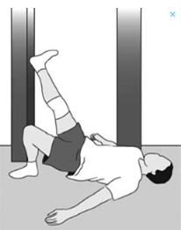

**Exercise Bike**

If you have access to an exercise bike, adjust the seat height so that the bottom of your foot just touches the pedal and complete a full revolution. As you become stronger, slowly increase the tension on the bike.

Start pedaling for 10 minutes a day. Increase the duration by one minute a day until you are pedaling for 20 minutes a day.

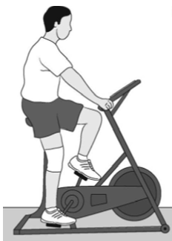

**Reproduced with permission from OrthoInfo. © American Academy of Orthopaedic Surgeons. http://www.orthoinfo.aaos.org.**

**Walking**

Walking is an excellent physical exercise activity for the middle stages of your recovery from surgery (after 2 weeks).

**Running**

Your doctor may recommend that you avoid running activities for a period of time after surgery in order to protect your knee. The length of the restriction will depend upon what type of procedure you had. For example, if you had an ACL reconstruction or meniscal repair, your running restriction will be different than if you had torn cartilage removed. Your doctor will talk with you about when it is safe to gradually resume your running activities.

**Pain or Swelling after Exercise**

As you increase the intensity of your exercise program, you may experience temporary setbacks. If your knee swells or hurts after a particular exercise activity, you should lessen or stop the activity until you feel better.

You should then Rest, Ice, Compress (with an elastic bandage), and Elevate your knee (R.I.C.E.). Contact your orthopaedic surgeon if your symptoms persist.