**Transurethral Resection**

**of the Prostate (TURP)**

**Patient Information Booklet**

**Please bring this book to your admission to the Hospital and to all of your appointments**

For Information Call

613-721-2000 extension 2920

Between 8:00 a.m. and 4:00 p.m.

Monday to Friday

This booklet is intended to provide you with information to prepare you for your hospital stay and discharge. Your safety and complete recovery is our priority following your surgery. For this reason, we ask you to follow these instructions. **PLEASE USE THIS BOOKLET AS A REFERENCE TOOL FOR ALL DATES AND TIMES AND BRING THIS BOOKLET WITH YOU TO ALL YOUR APPOINTMENTS AND ON YOUR SURGICAL DAY.**

Once you and/or your family have read the information, please feel free to ask your nurse or other members of the healthcare team any questions.

**Table of Contents**

Transurethral Resection of the Prostate (T.U.R.P) 4

Where do I go for my pre-operative assessment visit? 5

When is my appointment? 5

How do I prepare for my surgery? 8

What should I bring to the hospital? 9

What happens the day of my surgery? 9

What are ankle exercises and deep breathing exercises? 11

After Your Operation/Day of Surgery 11

Intravenous (IV) 11

Catheter and Continuous Bladder Irrigation (CBI) 11

Pain Management 13

Deep Vein Thrombosis (DVT) 14

At Home 15

Diet 15

Activity 15

Follow up 16

Additional Information 16

Care of Your Urinary Catheter, Drainage System and Leg Bag 17

# Transurethral Resection of the Prostate (T.U.R.P)

An enlarged prostate is considered to be a normal process of aging due to an increase in prostate tissue called Benign Prostatic Hypertrophy or B.P.H. When the prostate enlarges, it obstructs the flow of urine from the bladder through the urethra.

Common symptoms include:

* Passing small amounts of urine frequently,
* Poor stream,
* Up at night to empty your bladder frequently,
* Frequent bladder infections,
* Difficulty emptying bladder

These symptoms will not go away but only get worse with time. Your doctor has recommended a procedure called a Transurethral Resection of the Prostate or T.U.R.P. This procedure is the most common surgical procedure used for B.P.H.

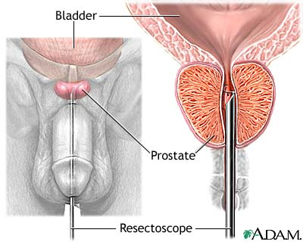

A Transurethral Resection of the Prostate (T.U.R.P) is performed under a spinal or general anesthetic. Your surgeon will put a special kind of telescope called a resectoscope, through the urethra to remove overgrown prostate tissue. Usually you are admitted to hospital for 1 to 3 days.

No incision is visible. Healing occurs at the site where the overgrown tissue has been removed. Scabs form at the site. Occasionally you may notice pieces of tissue/blood in your urine if these scabs fall off. This is all a part of healing.

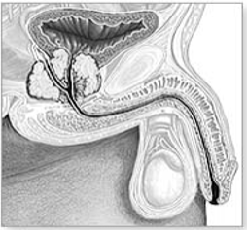 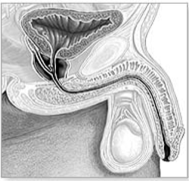

Before After

## Where do I go for my pre-operative assessment visit?

Report to the Queensway Carleton Hospital main lobby information desk. You will be directed to the Patient Registration Department to be registered and then to Pre-Operative Assessment Clinic (POAC).

## When is my appointment?

The Operating Room Scheduling Department at the Queensway Carleton Hospital will call you with your appointment information. Your Pre-Operative Assessment Clinic (POAC) appointment is on

at

If you have any questions about your appointment please call the Operating Room Scheduling Department: Monday to Friday, 8 a.m. to 4 p.m. at 613-721-2000, ext. 2614.

Your date of surgery is:

Call Queensway Carleton Hospital Operating Room Scheduling Department on the day before your surgery is scheduled to get the time for your admission. The number to call is 613-721-4840 between 11 a.m. and 3 p.m., Monday through Friday.

Call for your admission time on

**On the day of your Pre-Op Assessment Clinic visit we advise you to purchase 2 scrub brushes of Chlorhexidine 4% soap. They can be purchased at the QCH Gift Box on the main floor next to the front lobby.**

QCH Gift Box Hours

Monday to Friday 9 a.m. to 8 p.m.

Weekends 12 p.m. to 4 p.m.

**Antibiotic Resistant Bacteria**

**If you have ever been told you had or have an antibiotic resistant bacteria such as MRSA (Methicillin Resistant Staph Aureus)/ESBL (Extended Spectrum Beta-Lactamase producing bacteria), please tell the Pre-Operative Assessment Clinic (POAC) staff.**

Queensway Carleton Hospital is taking steps to prevent and control antibiotic resistant bacteria. This bacteria does not usually cause problems in healthy people, but it can cause infections in people who have weakened immune systems or have had major surgery. If you have stayed overnight in a healthcare facility within the last year, you will be screened for resistant bacteria at the time of your pre-operative visit.

**Health tips before surgery**

**Note**: Notify your surgeon if you develop a cold or any other illness before your surgery

This is important for your well-being and the safety of others because there is a risk for everyone if you go into surgery with an infectious process (cold or flu) in progress. Should your surgery be delayed, every effort will be made to have you rescheduled as soon as possible.

**Will I need to see a social worker?**

A social worker may call if you feel there are any issues that make it difficult for you to manage at home on discharge. If you are already on Home Care through the Local Health Integration Network Home and Community Care (LHIN HCC), please make sure that your Care Coordinator knows the date of your surgery.

If you live alone, you should plan to have someone stay with you overnight and to help make meals for a few days. You could also make meals ahead of time and freeze them. If you are worried about being alone, you may want to think about convalescent care in a retirement home. You can make these arrangements yourself or we can guide you to do it when you come to Pre-operative Assessment Clinic (POAC).

If you are the caregiver for someone else, please let us know at the time of your pre-operative visit.

If you have financial concerns that interfere with your discharge plans or other worries/stresses, please let us know. We can offer support and connect you with other services that you may not know about.

**Care Partner & Visitor Policy**

Please refer to the QCH Patient Handbook for detailed information about our care partner and Visitor Policy while you are at QCH.

**Please ensure that visitors are aware of the Queensway Carleton Hospital scent-free policy. Please do not bring scented flowers or wear scented products to the hospital.**

**Care Partner Contact**

Please discuss and decide with your family who will be the primary “contact” person. This should be the only person to phone the hospital staff regarding your condition. This person can then further contact the rest of your family and/or friends. The name of this person will be written on the chart. Please let your family and friends know who this person will be.

My family contact is:

Phone number: Home:

Work:

Cell:

# How do I prepare for my surgery?

You must follow these rules, or your surgery may be cancelled:

1. **Do not eat any solid food after midnight the night before your surgery.**
2. **If you are thirsty, you may drink clear fluids apple juice, water or ginger-ale™ until you leave to come to the hospital.**
3. **Please drink one cup (250 mLs or 8 oz) clear fluid apple juice, water or ginger-ale™, before leaving to come to hospital.**

You should take your regular prescription medications (no vitamins or herbal products) with water the morning of surgery as advised by the nurse or doctor you spoke with in POAC. **Bring your medications including any inhalers with you to the Hospital.**

You **must** stoptaking all supplements **except** vitamin D, calcium, or iron/iron supplements one week before surgery.

If you are taking Aspirin or other blood thinners, please inform your surgeon or nurse. You will be given specific instructions.

* **Skin preparation:**  Stop shaving in the operative area one week (7 days) before your surgery date. Shaving can cause tiny nicks in the skin that may allow germs to enter your body and cause an infection. **Do not use bath scents, powders or body lotions.**

Skin preparation:

1. The night before surgery bath or shower and wash your entire body using the Chlorhexidine sponge. Pat yourself dry with a fresh clean soft towel, put on clean pajamas or clothes and put on freshly laundered bed linens on your bed if you are able. **body with shading from the neck down**
2. The morning of surgery repeat your bath or shower using the Chlorhexidine 4% soap sponges

**(Chlorhexidine 4% soap sponges are available at the QCH Gift Box)**

* If you are a smoker, stop smoking at least 24 hours before your surgery. We can provide you with smoking cessation support to prevent nicotine withdrawal during your hospitalization.
* Do not drink alcohol at least 24 hours before surgery.
* On the day of surgery do not apply deodorant or insert contact lenses. **Please do not wear any scented products because some people are allergic to them.**
* Do not bring valuables (jewellery, credit cards, and money) to the hospital. We do not assume responsibility for lost or stolen articles.
* Arrange for someone to drive you to the hospital the day of surgery and drive you home on your discharge day.

## What should I bring to the hospital?

* Health card.
* All medications in their proper bottles including eye/ear drops, creams, inhalers, vitamins, herbals, and all over-the-counter medications.
* Dressing gown.
* Non-skid slippers.
* Comfortable clothing, for example: pajamas, and clothes to wear home.
* Your own reusable water bottle.
* Toothbrush, toothpaste, soap, shampoo, unscented deodorant, Kleenex™, razors. These items are not supplied by the hospital.
* Please label any equipment brought from home with your name on it.
* A list of allergies including the type of reaction.

## What happens the day of my surgery?

* On arrival to the hospital; report to the Patient Registration Department on the main floor. **Please bring your health card and medications with you**.
* From Patient Registration you will be taken to the Day Surgery Unit (DSU). A care partner can accompany you and remain with you until you go to surgery.
* After you arrive at the changing area, you will change into a hospital gown. Your clothes will be placed in a bag for later transfer to your room.
* A nurse will complete the paperwork for your admission to the hospital.
* The nurse will start an intravenous by inserting a small needle into your arm or hand. Prior to the surgery you will receive an antibiotic through the intravenous.
* A nurse or patient care assistant will take you to the Operating Room.
* You will talk to your anesthesiologist and surgeon in the waiting area.
* Your surgery will last about 1-2 hours.
* After your surgery, you will go to the Post Anesthetic Care Unit (PACU) for monitoring.
* The nurse will check your blood pressure, pulse, and operative site frequently.
* You will have an intravenous. A urinary catheter will be in place connected to a continuous bladder irrigation set up.
* You may have oxygen provided.
* If you feel any pain or nausea, inform the nurse. You can be given medication to help this.
* You may be drowsy after the surgery, as you become more alert, we will encourage you to do deep breathing and ankle exercises. These exercises will help to prevent complications.
* Your family will be able to visit you after you are admitted to your room. They can also bring any extra personal toiletries and clothing at this time.

## What are ankle exercises and deep breathing exercises?

**Ankle Exercises:**

Point your toes toward your head, then towards the foot of the bed. Make your feet go around in circles 5 times. This should be at least every hour while you are awake.

**Deep Breathing Exercises:**

Take a deep breath in through your nose, and slowly blow out through your mouth. Repeat these 3 times. This should be done every hour while you are awake for the first day, then every 2 hours for the next 1-2 days.

# 

# After Your Operation/Day of Surgery

No incision is visible. Healing occurs at the site where the overgrown tissue has been removed, scabs form at this site. Occasionally you may notice pieces of tissue or blood in your urine if these scabs fall off. This is all part of healing.

## Intravenous (IV)

An intravenous (IV) will be placed in your arm or hand before surgery. You will be encouraged to drink fluids. Regular food will be added to your diet when you can tolerate solid food.

You will have an intravenous (IV) for about 1-2 days. It is usually removed when you are able to eat and drink.

## Catheter and Continuous Bladder Irrigation (CBI)

You will have a catheter (a tube through your penis into your bladder). It will be a connected to a Catheter and Continuous Bladder Irrigation **(**CBI) setup. A solution will flow into your bladder constantly to reduce the chance of blood clots forming. The fluid will then drain out through the catheter into a collection bag. Do not be alarmed if the fluid draining out is bright red. It will gradually become lighter. Your catheter could become clogged with clots. If this happens, you may feel abdominal (stomach) pain, abdominal distension and you might notice your tube is not draining. Call your nurse who will flush your catheter. This problem does not always occur.

catheter, bladder irrigation, collection bag

Be careful not to pull on the catheter, especially when you get in and out of bed and walk.

A nurse will show you how to clean around your catheter with soap and water. Clean around your catheter twice a day until it is removed. This helps prevent infection.

The drainage bag collecting the fluid from your catheter will be emptied frequently. While the catheter is in place you may have a feeling of pressure or bladder fullness. The first few times you pass urine after the catheter is removed, a feeling of urgency, frequency and burning may occur. This often happens, but it will soon go away as healing takes place.

Your intravenous (IV) and catheter will usually be taken out a day or two after your surgery. At first, you may not have your usual control when passing your urine. You may have dribbling and pass your urine more often (frequency and urgency). This generally improves in a few weeks. It is very important that you drink lots of fluid (at least one glass of water an hour). This will dilute the blood in your urine and reduce the chance of clots forming.

## Pain Management

**Managing discomfort**

Most will have only mild or no discomfort. If you are having pain, tell your nurse so measures can be taken to help relieve it. You may be uncomfortable if a blood clot blocks the flow of urine out of your catheter. The nurse will irrigate the catheter for you.

**Spasms**

It is very common to experience bladder spasms (like muscle cramps that come and go). If this is a problem speak to your doctor/nurse.

**Irritation**

Irritation at the tip of the penis is common from the catheter. You can wash the tip of the penis with mild soap and water and use Polysporin™ ointment as needed.

**Nausea/Vomiting**

Some patients may experience an upset stomach and vomit. Tell your nurse and you will receive some medication for this.

**Activity**

You should be as active as possible both in and out of bed. The nurse will help you get out of bed and walk around, probably on the same day as your surgery. Your IV and catheter will need to go with you. Walking 3-4 times a day and taking deep breaths will help you recover. Your nurse will show you how to cough and deep breathe properly. Do this every hour while you are awake to decrease the risk of lung infection.

**Bowel Care**

Your surgery was done in an area right in front of your rectum. Do not force or strain to have a bowel movement. This could cause bleeding. Remember that you have an incision on the inside that needs time to heal. Try to prevent constipation.

* A stool softener, like Colace™, may be needed to make your bowel movements easier. This prevents straining that could cause bleeding. **If necessary ask for a laxative.**
* Eat a well-balanced diet with high fiber to prevent constipation. (fruits, vegetables and whole grain products)

**Pain scale ruler**

Your nurse will ask you to rate your pain on either the number or FACES scale (see below). Pain is rated from 0 (no pain) to 10 (worst pain).

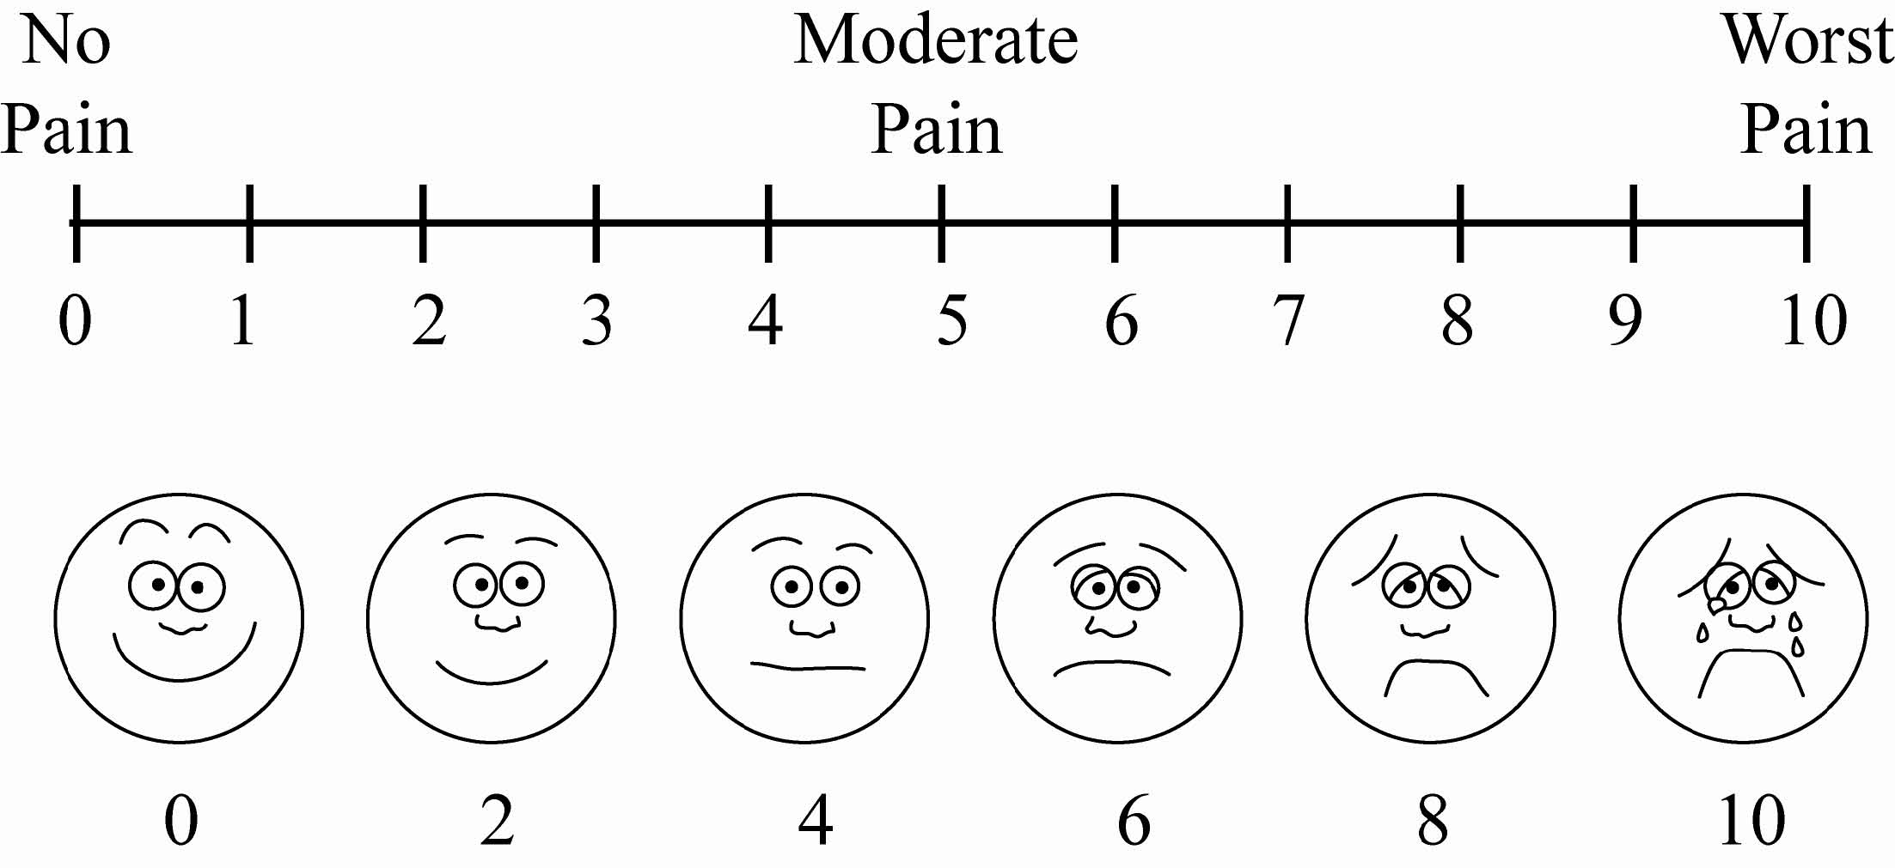

# Deep Vein Thrombosis (DVT)

Deep vein thrombosis can be a complication of surgery. It is a blood clot that may develop in a deep vein, usually in the leg. This can happen if the vein is damaged or if the flow of blood slows down or stops. A deep vein thrombosis (DVT) can cause pain in the leg and can lead to complications if it breaks off and travels in the blood stream to the lungs. When a clot forms it can either partially or totally block the blood flow in that vein.

Symptoms of a deep vein thrombosis (DVT) include:

* Swelling of the leg
* Warmth and redness of the leg
* Pain that is noticeable or worse when standing or walking

These symptoms are not always a sign of a deep vein thrombosis (DVT), but anyone who experiences them should contact their Doctor immediately or go to the nearest Emergency Department to be assessed. Your doctor will take steps to reduce your risk of developing a blood clot while you are in the hospital. These may include one of the following:

* + Blood thinning medication in the form of a daily injection
* Walking
* Ankle and leg exercises

Your doctor will advise you if you are to go home with blood thinners.

**Protecting your skin from pressure ulcers**

Are you at risk for developing a pressure ulcer (bed sore)? A pressure ulcer is a sore that develops, usually from sitting or lying in the same position for long periods of time or from sliding down in the bed. It is most often seen over the tailbone and heels. Some of the key things that can be done to help prevent these sores are to avoid sitting in bed with the head of the bed higher than 30 degrees for long periods of time, reposition yourself or ask for help, about every 2 hours, and use pillows under your legs, to avoid having your heels directly on the bed.

# At Home

You may see blood in your urine off and on for the next few weeks. This is normal. If your urine is pale yellow, drink your usual amount of fluids. If your urine is red or brown tinged, you should drink 8-10 glasses of fluid each day. This washes out your bladder and helps prevent infection.

Alcohol, spicy foods and caffeine, are all irritants to the bladder and cause burning, frequency and discomfort when voiding (passing urine).

## Diet

Good nutrition is important for healing, helps fight infection and ensures a smooth recovery.

Eat a high fiber diet to prevent constipation and straining. This includes whole grain cereals, bran, salads, and fruits/vegetables.

Choose *a* diet high in iron and Vitamin C at every meal. Vitamin C in juice or fruit helps the iron to be better absorbed. Iron rich foods include lean red meats, beans, green vegetables, whole grain breads and cereals like Shreddies™, All Bran™, Shredded Wheat™, and Cream of Wheat™.

Choose a protein and a milk product at each meal. Protein choices include fish, poultry, eggs, beans and nuts. Milk choices include milk, yogurt, cheese, puddings and ice cream.

## Activity

* Take frequent rest periods as necessary. Avoid sitting for long periods.
* You may go for short walks and be reasonably active with frequent rest periods.
* Avoid any strenuous activity and no heavy lifting for four weeks, (eg. shoveling, digging or lifting over 7kg/15 lbs). There are no restrictions on climbing stairs. Your doctor will advise you when you can resume sports/return to work. Gradually resume your regular activities like light housekeeping after 2 weeks.
* Avoid long car rides for 3-4 weeks.
* Sex should be avoided for 3-4 weeks or as per your doctor’s advice.

## Follow up

Your doctor will tell you when to make a follow up appointment to see him/her after surgery.

IF YOU HAVE ANY QUESTIONS OR CONCERNS, PLEASE CALL YOUR SURGEON OR GO TO THE NEAREST EMERGENCY DEPARTMENT IN THE CASE OF ANY EMERGENCY.

# Additional Information

1. If given a prescription to help prevent infection, take until completely finished. Watch for signs and symptoms of infection: fever (greater than 38˚C or 100.4˚F, chills, cloudy foul-smelling urine, pain in the abdomen or bladder. If you have any of these symptoms, contact your surgeon or go to the nearest Emergency Department if you cannot reach your surgeon.
2. It is normal for up to 6-8 weeks to notice blood in your urine off and on as a part of healing. As the surgical site heals, scabs may fall off and you will notice blood or pieces of tissue in your urine. If you do too much physical activity, for example, walking – you might notice more blood or tissue in your urine. Rest and drink lots of fluids.

If you have a lot of blood in your urine, clots or can’t empty your bladder, go to the nearest Emergency Department.

1. If you go home with a catheter, your nurse will review “Care of your urinary catheter, drainage system and leg bag” with you. If after the catheter is removed, you cannot empty your bladder, call your surgeon or go to the nearest Emergency Department.
2. Your medications – continue to take all prescribed medications unless instructed otherwise by your Doctor. **CHECK WITH YOUR DOCTOR BEFORE TAKING ASA (ASPIRIN™) OR ANY BLOOD THINNERS AFTER SURGERY.**

## Care of Your Urinary Catheter, Drainage System and Leg Bag

Your urinary catheter is a thin tube that enters the bladder and is held in place by a tiny balloon filled with water. The urinary catheter continually drains urine from your bladder. These instructions will tell you how to look after your urinary catheter when you go home. Always wash your hands before you start and after you finish your catheter care.

**Personal hygiene:**

You can shower and go back to your normal activities, unless you are told otherwise.

**How to look after your catheter:**

Your catheter needs to be cleaned twice daily, using soap and water. Wash the skin around your catheter and the catheter tube with warm water, soap and a clean washcloth. Rinse with warm water to remove soap. While you are washing this area, you should watch for signs of infection such as: redness, tenderness, swelling or drainage. After you clean your catheter you should also wash around your rectum with and after each bowel movement.

**Report problems early:**

Call your doctor right away if you have problems such as:

* a continuous leakage of urine from around the catheter (a little leakage for a short time may be due to a bladder spasm and is nothing to worry about)
* pain and fullness in your lower abdomen
* a decrease in the amount of urine flowing or no urine draining into catheter bag
* blood or clots in your urine that do not clear with increasing fluid intake
* elevated temperature (above 38oCor 100.4oF), fever and/or chills lasting more than 24 hours
* cloudy, foul smelling urine

**Diet:**

It is important to drink lots of fluids, ideally 4-8 glasses per day. It is also important to eat a diet that has lots of fibre to avoid constipation. Sources of fiber are fruits, vegetables and whole grain breads and cereals (e.g. All Bran™, Bran Flakes, Shreddies™ and Shredded Wheat).

**Additional information:**

**Connecting, disconnecting, emptying of the overnight drainage bag**

* Always wash your hands before you start and after you are finished your catheter care.
* Your urinary catheter is attached to a drainage tube that leads to a collection bag. At bedtime, some patients use an overnight collection bag (rather than a leg bag) as it holds more urine so you can sleep for 8 hours without emptying it.
* You can attach the urinary catheter tubing to your inner thigh using non-allergic tape. These are securement devices which can be purchased from your local pharmacy to help with this.

Allow slack in catheter so that you won’t pull on the urinary catheter when you move.

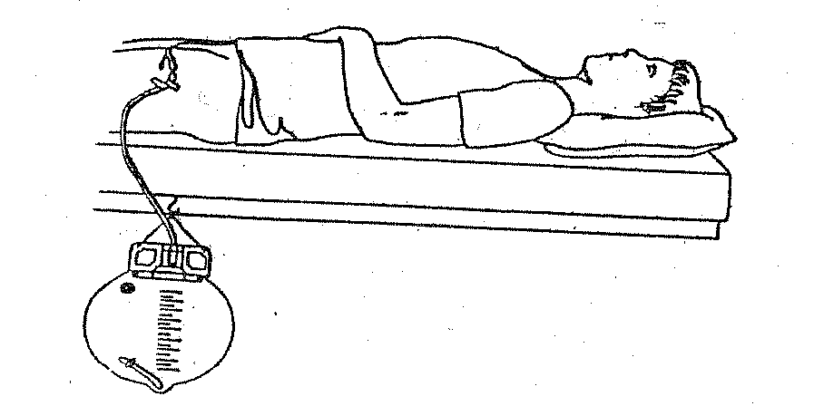

**Before going to bed**

1. Hang the overnight collection drainage bag by its hook on the side of the bed. The collection bag should never lie on the floor. If you are not able to hook the collection bag at the side of the bed place a clean towel on the floor next to the bed. Then place the collection bag on the clean towel. When you get into bed, arrange the drainage tubing so it doesn’t kink or loop. Keep the collection bag below the level of your bladder at all times to prevent backflow of urine into your bladder. Always make sure that the clamp at the bottom of the collection bag is closed.
2. In the morning, when you are ready to change to the leg bag, you should empty the nighttime collection bag first. To do this, remove the clamp at the bottom of the bag from its sleeve (without touching the tip) and unclamp it.
3. Let the urine drain into the toilet (or into a measuring container, if you have been given instructions to measure). Do not let the end of the clamp touch the toilet or container.
4. When the collection bag is completely empty, clean the end of the clamp with an alcohol pad and put it back into its sleeve.

**Connecting, disconnecting, emptying of the leg drainage bag**

1. When changing the collection bag, all connections should be wiped with an alcohol pad available for purchase from your Pharmacy.
2. Wash your hands with soap and water.
3. Pinch the catheter closed between your fingers.
4. Remove the old bag.
5. Wipe the end of the catheter with a fresh alcohol pad.
6. Wipe the tip of the new bag with a second new alcohol pad.
7. Connect the new bag.
8. Stop pinching the catheter and wash your hands again.
9. Make sure there are no bends or kinks in the catheter tube.
10. Attach the leg bag to your leg using the straps included. Do not make the straps too tight, make sure they are comfortable. Alternate the leg bag from one side to the other each day.

**leg bag attached to the leg**

**Emptying the leg bag**

1. Wash your hands.
2. Open the drainage clamp at the end of the bag and drain all the urine into the toilet (or into a measuring container if necessary). Do not let the end of the drainage clamp touch your hands, toilet or the container.
3. After the leg bag is completely empty, clean the end of the drainage clamp with alcohol pad and close it.
4. Wash your hands after you are finished.

**Cleaning the drainage bags**

1. You need cool water, mild liquid soap and white vinegar.
2. Wash your hands.
3. Ensure the clamp is closed at the bottom of the bag.
4. Using a clean funnel or a poultry baster, pour mild soap and water

solution into the inside of the bag through the collection tube.

1. Wash the inside of the bag with soap and cool water, (hot water may damage the bag).
2. Rinse the bag with cool water to remove all soap.
3. Mix 1 cup of cool water with 1 cup of white vinegar.
4. Fill the bag halfway with the vinegar solution and shake it.
5. Let the bag sit for 30 minutes.
6. Empty the bag and rinse with cool water.
7. Hang the bag to dry.
8. Wash your hands.