

Queensway Carleton

Hospital

**Radical Cystectomy Urinary Diversion Ileal Conduit**

**Patient Information Booklet**

**Please bring this book to your admission to the Hospital and to all of your appointments**

For Information Call

613-721-2000 extension 2920

Between 8:00 a.m. and 4:00 p.m.

Monday to Friday

Table of Contents

Introduction 4

Your condition and your surgery 5

Ileal Conduit Urinary Diversion 7

Antibiotic resistant bacteria 7

Will I need to see a social worker? 8

Preparations before surgery 9

Health tips before surgery 9

What should I bring to the hospital 9

The day prior to surgery 10

Day of surgery 13

When you arrive at the hospital 13

After surgery: Recovery Room 13

After surgery 14

Deep vein thrombosis (DVT) 14

Protecting your skin from pressure injuries 15

Moving and positioning 15

Getting out of bed 15

Pain management 17

Diet 17

Urostomy 17

Sequential compression device (SCD) 17

Incision 18

Drains 18

Activity while in hospital 18

Ileal conduit care 18

Preparing for discharge 19

Discharge planning 19

After discharge 20

Activity 20

Medications 20

Incision care 21

Diet 21

Caring for your Jackson-Pratt ® (JP) drain 22

Care of your Ileal conduit 22

Supplies 23

Before you leave the hospital 23

When you get home 23

How to change your appliance (pouch) 24

How to empty your pouch 25

Night drainage system 25

Cleaning the night drainage bag 25

When you are at home 26

Where and what to buy? 27

Anticoagulant medications 27

Injection tips 28

When should I call my community NSWOC? 30

For information call

Before your surgery:

Contact your surgeon’s office or Pre-Operative Assessment Clinic 613-721-2000 ext. 2920 between 8:00 a.m. to 4:00 p.m. Monday to Friday

After your surgery:

Contact your surgeon’s office

# Introduction

Welcome to the Queensway Carleton Hospital.

You are being admitted for Radical Cystectomy Urinary Diversion Ileal Conduit surgery. The length of your hospital stay depends on your surgery. You can expect a stay of approximately 6-7 days. Your safety and complete recovery is our priority following your surgery. This booklet is intended to provide you with information to prepare you for your hospital stay and discharge.

Use this booklet to record appointment/surgery dates and times. Bring it to all your appointments and to your surgery.

The information in this booklet is for educational purposes. It is not intended to replace the advice or instructions of a healthcare professional. Contact your surgeon if you have any questions about your care.

This booklet is part of the Best Practices in General Surgery‘s (BPIGS) Enhanced Recovery after surgery (ERAS) program. The ERAS program includes surgeons, anesthesiologists, nurses, dietitians, and other allied health professionals. The goal of this program is to decrease post-operative complications and speed your recovery. This will allow you to go home sooner after surgery and improve your overall satisfaction with the care you receive. This is accomplished by standardizing practices based on evidence.

**The Healthcare Team**

**Surgeon**

Your surgeon will discuss your surgery, recovery, discharge and follow-up. They will answer any questions you might have. Your surgeon will oversee your care with the other healthcare providers.

**Anesthesiologist**

During your pre-admission appointment, the anesthesiologist will discuss the anesthetic for your surgery and pain management after surgery.

**Nurses**

Registered nurses and/or registered practical nurses will care for you before, during and after surgery. They will provide emotional support, teaching, medications, and nursing care.

**Nurse Specialized in Ostomy Continence (NSWOC)**

Your surgeon will arrange for you to see the nurse specialized in Wound Ostomy Continence (NSWOC) care at QCH for pre-operative stoma marking by the physician. This marking will stay on until your surgery as ordered by your surgeon.

**Your date of surgery is**

Call the Queensway Carleton Hospital Operating Room Scheduling Department the weekday (Monday to Friday) before surgery to determine the time of admission.

Call for your admission time on ___________________________(date)

**The number to call is 613-721-4840 between 11:00 a.m. and 3:00 p.m.**

**What if I’m on a special diet?**

Tell the nurse if you have special dietary restrictions and if necessary, the nurse will contact the dietitian.

# Your condition and your surgery

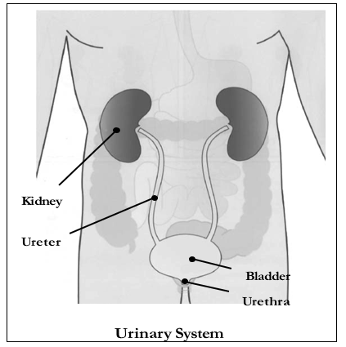

You have been diagnosed with bladder cancer and your Urologist has suggested a radical cystectomy. Radical cystectomy removes the entire bladder, nearby lymph nodes, and any surrounding organs that contain cancerous cells.

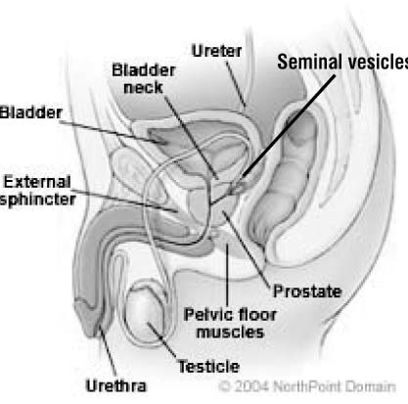

In men, the organs that are removed are the prostate and the seminal vesicles which is a pair of glands on each side of the bladder.

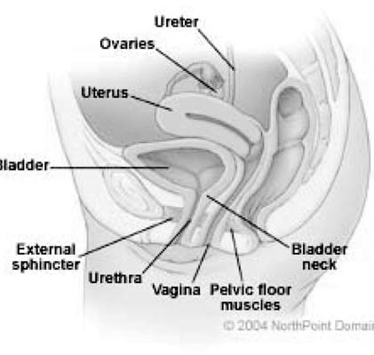

In women, the uterus, the ovaries, and part of the vagina are removed.

Following a cystectomy, the urologist will create a **urinary diversion**. The different urinary diversions are:

* Ileal conduit
* Continent pouch reservoir
* Neobladder

## Ileal Conduit Urinary Diversion

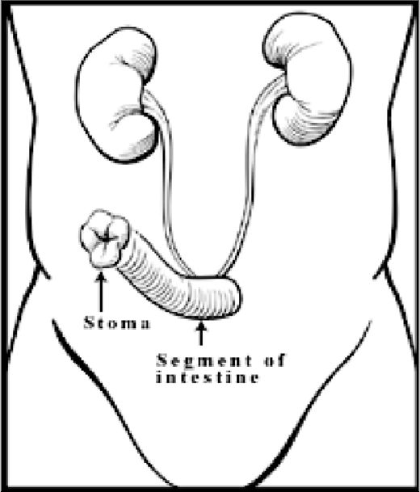

Once the bladder is removed, in an ileal conduit procedure, the urologist takes a short segment of your small bowel (intestine) and reconnects the remaining bowel so that it functions normally. The urologist uses about 6 to 8 inches (15 to 20 cm) of your small bowel. You have about 20 feet (6 meters) of bowel, so you still have plenty of bowel left to digest food.

The short segment of bowel or ileum that was removed is now used to drain the urine to the outside of the body. The ureters that drain the urine from the kidneys are attached to this part of ileum. The ileum is then brought through an opening on your abdomen. The urine flows through the newly formed ileal conduit and the stoma into an external pouch. A few drops of urine flow from the stoma every 10 to 15 seconds. You will not feel the urge to void and you will be unable to start or stop the flow of urine.

## Antibiotic resistant bacteria

**If you have ever been told you had or have an antibiotic resistant bacteria such as MRSA (Methicillin Resistant Staph Aureus)/ESBL (Extended Spectrum Beta-Lactamase producing bacteria), please tell the Pre Operative Assessment Clinic (POAC) staff.**

Queensway Carleton Hospital is taking steps to prevent and control antibiotic resistant bacteria. These bacteria do not usually cause problems in healthy people but can cause infections in people who have weakened immune systems or have had major surgery. If you have stayed overnight in a healthcare facility within the last year, you will be screened for resistant bacteria at the time of your pre-operative visit.

## Will I need to see a social worker?

A social worker may call if you feel there are any issues that make it difficult for you to manage at home on discharge. If you are already on Home Care through the Local Health Integration Network Home and Community Care (LHIN HCC), please make sure that your Care Coordinator knows the date of your surgery.

If you live alone, you should plan to have someone stay with you overnight and to help make meals for a few days. You could also make meals ahead of time and freeze them. If you are worried about being alone, you may want to think about convalescent care in a retirement home. You can make these arrangements yourself or we can guide you to do it when you come to Pre-operative Assessment Clinic (POAC).

If you are the caregiver for someone else, please let us know at the time of your pre-operative visit.

If you have financial concerns that interfere with your discharge plans or other worries/stresses, please let us know. We can offer support and connect you with other services that you may not know about.

**Family contact**

Please discuss and decide with your family who will be the primary contact person. This should be the only person to phone the hospital staff regarding your condition. This person can further contact the rest of your family and/or friends. This name will be written on the chart. Please let your family and friends know who this person is.

My family contact is:

Phone number:

Home:

Work:

Cell:

Patient recovery can be enhanced by visits from family members, but please remember your recovery is also aided by plenty of rest. Please be courteous and have consideration for your fellow patients regarding the number of visitors coming to see you. Patients and their families are asked to adhere to the visiting hours and to limit visitors to two at the bedside at one time.

# 

# Preparations before surgery

## Health tips before surgery

**Notify your surgeon before your surgery if you develop a cold or any other illness**

This is important for your well being and the safety of others because there is a risk to everyone if you go into surgery with an infectious process (cold or flu). Should your surgery be delayed, every effort will be made to have you rescheduled as soon as possible.

It is also important to inform your surgeon if you have any burns, rashes or skin irritation, which may need to be treated before your surgery.

If you need to speak to a pre-operative nurse **BEFORE** surgery you may call 613-721-2000, extension 2920 between 8:00 a.m. to 4:00 p.m., Monday to Friday (except holidays).

**We will advise you to purchase two scrub brushes of Chlorhexidine 4% soap. They can be purchased at the QCH Gift Box on the main floor next to the front lobby.**

QCH Gift Box Hours

Monday to Friday 9 a.m. to 8 p.m.

Weekends 12 p.m. to 4 p.m.

## What should I bring to the hospital

Please bring:

* A housecoat or dressing gown and slippers.
* Toothbrush, toothpaste, soap, shampoo, deodorant, shaving cream, razor, Kleenex™ or facial tissue. These items are not supplied by the hospital.
* All your current medications in proper bottles, including non-prescription medication (including creams, eye drops, inhalers/puffers, vitamins, patches, and herbal products).
* A list of allergies including type of reactions.
* 2 packs of chewing gum. Chewing gum may promote digestive function.
* A reusable water bottle.

# 

# The day prior to surgery

The day prior to as well as the day of surgery you will only drink clear fluids by mouth. You are **not to eat any solid foods**. All juices or fluids must be clear (able to see through). Examples of clear fluids include water, apple juice, broth, white cranberry juice and ginger ale.

**One day before surgery (Clear Fluid Diet)**

**Date:** 🞎check box when complete

Purpose: To decrease the amount of stool matter in the bowel.

Avoid

* Milk products
* Solid foods
* Juices / fluids with pulp (for example - no tomato or orange juice)
* Alcohol

On a clear fluid diet, you are encouraged to drink at least 8 glasses of fluids throughout the day to prevent dehydration.

**If you are a diabetic:** Check with your doctor about taking your usual medications.

|  |  |
| --- | --- |
| **Fluids Allowed** | **Fluids Not Allowed** |
| Clear juices (apple, white cranberry, peach, white grape juice) | Milk or milk products (milkshakes, custards, yogurt) |
| Water | Cream soups |
| Clear broth | Tomato juice |
| Sodas | Orange juice |
| Decaffeinated coffee or tea | Oatmeal or Cream of Wheat™ |
| Water popsicles | Grapefruit juice |
| Lemonade | Alcohol |
| Kool Aid™ | Do not drink or eat anything with |
| Sports drinks (Powerade™, Gatorade™) | red or purple coloring. This can cause discoloration in the bowel |
| Hard candies |  |
| Clear gelatin (Jell-O™) with no added fruit |  |

**Sample Menu – Clear Fluid Diet**

|  |  |
| --- | --- |
| Breakfast: | * 8 oz/250 mL clear juice – example apple, peach, white cranberry * 4 oz/120 mL Jell-O™ * Decaffeinated coffee or tea, with sugar, sweetener or honey |
| Snack: | * 4 oz/120 mL clear juice * 4 oz soda e.g. ginger ale, 7-Up™ |
| Lunch: | * 8 oz/250 mL clear broth (chicken or beef) * 4 oz/120 mL clear juice (no pulp) * 4 oz/120 mL Jell-O™ * 4 oz/120 mL ginger ale or 7-Up™ * Decaffeinated tea with sugar, sweetener or honey |
| Snack: | * 4 oz/120 mL ginger ale or 7-Up™ or Powerade™ * 4 oz/120 mL clear juices (no pulp) |
| Supper: | * 8 oz/250 mL clear broth (chicken or beef) * 4 oz/120 mL clear juice (no pulp) * 4 oz/120 mL Jell-O™/water popsicle * 4 oz/120 mL ginger ale or 7-Up™ |
| Snack: | * 4 oz/120 mL ginger ale or 7-Up™ or Powerade™ * 4 oz/120 mL clear juices (apple juice) * Water popsicle, club soda or water |

Remember to drink plenty of fluids the day before surgery, at least 6 - 8 glasses.

The pre-operative assessment clinic nurse will provide you with instructions, as ordered by your surgeon, to give yourself 2 fleet enemas the evening before your surgery.

* **If you are thirsty, you may drink clear fluids apple juice, water or ginger-ale until you leave to come to the hospital.**
* **Please drink one cup (250 mLs) 8 ounces clear fluid e.g. apple juice, water or ginger-ale, before leaving to come to hospital.**
* You should take your regular prescription medications (no vitamins or herbal products) with water the morning of surgery as advised by the nurse or doctor you spoke with in POAC.
* You **must** stoptaking all supplements **except** vitamin D, calcium, or iron/iron supplements one week before surgery.
* If you are taking Aspirin or other blood thinners, please inform your surgeon or nurse. You will be given specific instructions.
* If you are a smoker, try to stop smoking at least 24 hours before your surgery. We can provide you with smoking cessation support to prevent nicotine withdrawal during your hospitalization.
* No alcohol for at least 24 hours before surgery.
* Have a bath or shower before coming to the hospital.

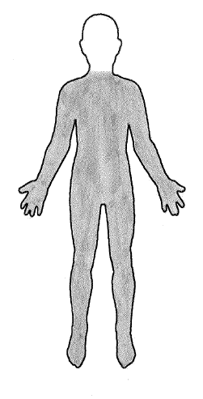

**Skin preparation:**  Stop shaving in the operative area one week (7 days) before your surgery date. Shaving can cause tiny nicks in the skin that may allow germs to enter your body and cause an infection. **Do not use bath scents, powders or body lotions.**

Skin preparation:

1. The night before surgery bath or shower and wash your entire body using the Chlorhexidine soap. Pat yourself dry with a fresh clean soft towel, put on clean pajamas or clothes and put freshly laundered bed linens on your bed if you are able.
2. The morning of surgery repeat your bath or shower using Chlorhexidine 4% soap sponges.

**(Chlorhexidine 4% soap sponges are available at the QCH Gift Box)**

* On the day of surgery do not wear any deodorant, lotions, powders, nail polish or contact lenses. **DO NOT WEAR ANY SCENTED PRODUCTS AS THE HOSPITAL HAS A SCENT FREE POLICY.**
* Remove all jewellery, including body piercing jewellery.
* Do not bring any valuables to the hospital (credit cards, money or jewellery). We do not take responsibility for lost or stolen articles.
* Bring only the minimum personal belongings (clothing, etc.) with you to Hospital. Patient rooms are small and there is limited storage.
* Arrange for someone to drive you to the Hospital the day of surgery and home on your discharge day.

# Day of surgery

## When you arrive at the hospital

* From Patient Registration, you will be directed to the Day Surgery Unit (DSU). One care partner can accompany you and stay with you once you are admitted. You may designate this care partner to be the person to call after surgery.
* The surgeon, anesthetist and operating room (OR) nurse will see you and answer any questions that you may have. The surgeon will mark the site that they will be operating on.

## After surgery: Recovery Room

* Your operation can last approximately 6 to 8 hours.
* After your surgery, you will go the Post Anesthetic Care Unit (PACU).
* Your nurse monitors your vital signs, including your pulse and blood pressure and will look at your incision frequently.
* The nurse will check the circulation, sensation and movement of both legs. If you have an epidural for pain management, your legs may feel heavy.
* If you feel any pain, nausea or itchiness tell your nurse. You will be given medication to help you feel better.
* You may be drowsy after the surgery, as you become more alert we will encourage you to do deep breathing and ankle exercises. These exercises will help to prevent post-operative complications.
* If you have sleep apnea, you may be required to be monitored in the PACU for a longer period of time. If you have your own CPAP machine, you need to bring it with you to the hospital.
* Your nurse may take a blood sample to check your blood levels.
* You will be transferred to your room when the nurse determines it is safe to move you.
* If you are being admitted to the hospital, you will be transferred to your room when your nurse determines it is safe to move you and when your room is ready. Sometimes there are delays due to the late discharge of other patients.

**Pain scale ruler**

Your nurse will ask you to rate your pain on either the number or FACES scale (see below). Pain is rated from 0 (no pain) to 10 (worst pain).

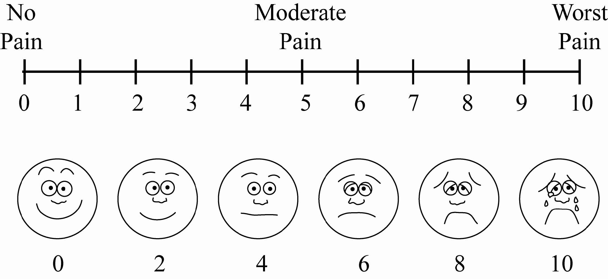

# After surgery

## Deep vein thrombosis (DVT)

Deep Vein Thrombosis (DVT) is a blood clot in a deep vein and is a major health concern that should be discussed with your physician.

You may be at risk for developing a DVT for any of the following reasons:

* Recent surgery
* Immobility
* Previous DVT
* Problems with circulation
* Obesity
* Increasing age
* Acute medical illness

DVT’s most commonly occur in the legs, usually the calf. Signs and symptoms to watch for include: calf pain or swelling, redness or discolouration, a knot in the calf that you can feel and that is warm to touch, fever, shortness of breath, rapid heart rate or chest pain.

If you experience any of these symptoms go to the nearest Emergency Department or call 911 for immediate assistance.

**Ankle exercises**

Point your toes toward your head, then toward the foot of the bed. Make your feet go around in circles 5 times. This exercise should be done at least every hour while you are awake.

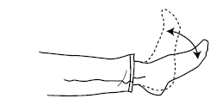

**Deep breathing exercises**

Take a deep breath in through your nose, and slowly blow out through your mouth. Repeat these 3 times. This should be done every hour while you are awake for the first day, then every 2 hours for the next 1-2 days.

## Protecting your skin from pressure injuries

A pressure injury is a sore (bed sore) that develops from sitting or lying in the same position for long periods of time or from sliding down in the bed. It is most often seen over the tailbone and heels. Some of the key things that can be done to help prevent these sores are: avoid sitting in bed with the head of the bed higher than 30 degrees for long periods of time, reposition yourself or ask for help to do so at least every 2 hours, and use pillows under your legs, to avoid having your heels directly on the bed.

## Moving and positioning

It is important to move and reposition yourself while you are in bed. Move every 2 hours while awake.

* Support your incision with a small blanket or pillow.
* Bend your knees and roll from your side to your back.

## Getting out of bed

Your nurse will get you out of bed as soon as you are able. Walking and exercise are important to your recovery. For safety reasons your bed rails will remain raised for the first 24 hours after surgery. The nurse call-button will be within your reach so you can push the button if you need assistance.

**How do I get out of bed?**

The correct way to get out of bed following surgery is described below with diagrams to illustrate the process:

* Roll onto your side and bring your knees up towards your abdomen. picture of a man lying on a bed on his side
* Place your upper hand on the bed below your elbow.
* Raise your upper body off the bed by pushing down on the bed with your hand.

Picture of a man lying on a bed on his side and is using his arm to push up his body

* Swing your feet and legs over the edge of the bed and bring your body to a sitting position.

Picture of a man sitting on a bed

* Once in a sitting position, take a few breaths and ensure your balance is good before you attempt to stand.
* Slide your bottom to the edge of the bed.
* Stand up keeping your back as straight as possible.
* When getting back into bed, reverse the process.

## Pain management

Pain management is very important for a quick and speedy recovery. Pain medication is given as often as required in order to make you comfortable enough so that you will be able to take a deep breath and move with minimal discomfort. Inform your nurse if you are uncomfortable or having pain.

You will be discharged home with a prescription for medication to manage your pain.

You may also experience bladder spasms, which may feel like a muscle cramp that comes and goes in waves. The spasms can be relieved with medication if they become severe.

If your pain medication seems to stop working, call your nurse to check and assess your level of pain. If you are still uncomfortable and the nurse has checked and assessed your pain level your nurse will notify your doctor and your dose will be adjusted as required.

## Diet

You will progress to a regular diet soon after surgery. There is no need for a special diet unless you were on a special diet prior to surgery. It may take some time before your appetite returns to normal. Eating can sometimes be easier if you eat 5 – 6 smaller meals throughout the day.

Your body will also need more nutrients, energy and protein when recovering from surgery. Try to eat protein rich foods at each meal and snack (examples include milk, yogurt, cheese, eggs, meat, fish, poultry, tofu or lentils and beans). If you are not able to eat enough food you can try nutritional supplement drinks such as Ensure or Boost.

After surgery it is also important to drink plenty of fluids. You need to drink at least 2 litres (8 cups) of fluid per day unless directed otherwise.

## Urostomy

You will meet with a nurse specialist in Wound, Ostomy, and Continence care after surgery to assist with answering any questions you may have about your new bladder diversion. Prior to discharge, you will be given a kit with some ostomy supplies to get you started. After discharge you will have home care nurses come to your house to teach you more about your ostomy.

## Sequential compression device (SCD)

Because you will remain in bed for the first day you may have a Sequential Compression Device. This device massages the legs at various intervals. This helps prevent blood clots and improves blood circulation in your legs. Once you are up sitting in a chair or walking this device will no longer be used.

## 

## Incision

A dressing will cover your incision. The nurse may change your dressing as needed or if it becomes soiled. On the third day after your surgery, the Nurse will remove the dressing and leave it open to air. If there is still drainage from the incision, the Nurse may put a dry gauze dressing on your incision.

## Drains

You will have one or two drains in your abdomen. These drains remove excess fluid from the surgical area. These drains are called Jackson Pratt™ (JP) drains. The amount of drainage will be monitored and recorded by the Nurse. These drains are often removed before you go home.

## Activity while in hospital

* One day after your surgery you will be helped to sit on the side, stand and march at the bedside and/or sit up in the chair.
* On Post-op Day 2 you will be assisted in taking short walks in the hall at least two times.
* On Post-op Day 3 and 4, you should be taking 3-4 short walks with assistance.
* Over the next few days in hospital you should continue to increase your activity and endurance as you tolerate.

## Ileal conduit care

You will have an ostomy appliance (pouch) over your ostomy to collect the urine. The nurse will check your pouch daily and empty when necessary. The pouch is connected to a large drainage bag for the first days after the surgery. After the surgery, the nurse will start teaching you how to remove the night drainage bag for daytime and how to put it back for nighttime. The drainage bag during the night will give you a better night’s sleep as the bag capacity is larger than the pouch and does not need to be emptied as often. You will also learn how to empty the pouch.

The nurse will provide you with information and support about care of your Urostomy. You will be given a discharge kit with a couple ostomy supplies to go home with. A NSWOC (Ostomy nurse) will see you while in hospital to answer any questions you may have. Home care will be arranged for you while in hospital to answer any further question you may have. You will be seen by a nurse at home to help support you with your new ostomy.

The stoma will produce a thick jelly-like substance called mucous. This is because the bowel produces mucous constantly and the piece of small bowel the Urologist uses to create the stoma will continue doing this. As time passes, the amount of mucous will gradually decrease, though it will not stop completely.

There will be 2 stents (narrow hard tubes) coming out through your stoma. These stents are inserted to ensure proper healing of your urinary diversion reconstruction. Most times these stents are removed in the hospital before you go home. On occasion your Urologist may choose to leave yours in longer. If the tubes come out inadvertently, you need not worry as it will not cause damage. If you are discharged home with them and this happens at home, you should call your Urologist’s office to inform them.

# Preparing for discharge

When you are discharged from Hospital, you may need help at home. It is best to make arrangements for housekeeping before being admitted to Hospital. Discuss your discharge plans with your nurse.

You are responsible for your own transportation home. You may require help to do your shopping and house chores from a family member or friend for 4 to 6 weeks after surgery. **Arrangements for convalescence care, if desired, should be made before you are admitted to the hospital.** The social worker is available through the Social Work Office, 613-721-2000 ext. 3753 or 3771, to help with the arrangements if necessary.

## Discharge planning

You may have a number of concerns related to how you will manage once you return home. If you have such concerns, or any others, you may request to see a social worker as part of your discharge plan. Please let your nurse know.

Arrange for someone to pick you up on the day of discharge. You will receive a prescription for medication and a follow-up appointment to see your surgeon in about 2 to 3 weeks.

Be sure you understand about:

* Activity restrictions
* Medication you are to take
* Incision care
* Diet
* When to call your doctor
* Follow-up appointment
* Ostomy care

## 

# After discharge

## Activity

* Take frequent rest periods as necessary. Let your body be your guide.
* Continue doing the deep breathing and coughing, ankle and calf pumping exercises.
* You may climb stairs but do this slowly.
* Do light activities for four to six weeks. Avoid strenuous exercise including heavy lifting (nothing greater than 10 pounds or 4.5 kgs), lifting grocery bags, shoveling snow, or pushing a lawn mower until you have seen your doctor on your follow-up visit.
* Increase your walking distance each day.
* Resume your usual activities gradually over six weeks. Discuss any specific concerns with your doctor including when to resume sexual activity.
* A good rule is to not drive until you are pain free, this is because when you are having pain, it will change the way you would react to something. Take breaks during long car drives every couple hours, get out of the car and walk around.

## Medications

* Take your pain medication as required. It is normal to experience some wound discomfort for a period of time after discharge.
* Constipation may be a side effect of your pain pills. Increase the fibre in your diet and drink plenty of fluids to help prevent constipation. Good sources of fiber are fruits, vegetables and whole grain breads and cereals (All Bran™, Bran Flakes, Shreddies™ and Shredded Wheat). You may also purchase an over the counter stool softener like Colace™ or a mild laxative if needed
* Do not drive a vehicle if you are taking narcotics, (e.g. Tylenol™ #3, Hydromorphone™, Percocet™). Narcotics may slow your reaction time and affect your judgment.

## 

## Incision care

* You may take a shower. Clean your incision with mild soap and water. Dry well.
* Observe the incision for redness, tenderness, or drainage. Contact your Urologist if problems with your incision develop.
* Swelling or bruising around the incision is common and will go away with time.
* If you have had surgery, your incision will be closed with staples (clips) or stitches. It will likely be covered with steri-strips (small tape-like bandages) and have a light (Mepore™) dressing over top.
* It is normal to have a clear, reddish, yellow drainage on the dressing.
* Steri-strips often peel off on their own in about 10 days. If they do not, leave them until you see the surgeon.
* Change your dressing after showering
* When changing the dressing, follow these instructions:
* Wash your hands well before and after changing or removing dressings or touching your incision.
* Use 4x4 gauze, and surgical tape.
* Keep the surgical area clean and dry at all times.
* Your surgeon or community nurse or family physician will remove the staples from your incision usually 10-14 days after your surgery. Do not get your incision wet for 24 hours after removal of your staples. After that, you may shower/bath daily.
* Do not soak the incision in a tub bath or a swimming pool or apply oils, creams, or lotions to your incision for at least two weeks after stitches/staples are removed and your incision is completely healed.
* Expect some swelling and bruising around the incision or in your upper thigh or groin, this can last a few weeks.

## 

## Diet

* Return to normal eating habits. A well balanced diet is encouraged to promote healing.
* Drink plenty of fluids, at least 2 liters per day to help prevent mucous build up.

## Caring for your Jackson-Pratt ® (JP) drain

You may go home with a Jackson Pratt® (JP) drain in place in your abdomen. These drains are used to remove fluid that would otherwise collect at the surgical site and are usually removed by your nurse before you go home. If you are to go home with your drain still in, your nurse will teach you how to care for it at home and will provide you with a teaching sheet on how to care for it entitled: “Care of your Surgical Drainage System”.

# Care of your Ileal conduit

**Basic care**

You don’t want the skin around the stoma exposed to urine for extended periods of time as it can result in skin breakdown. The goal is to prevent your skin from being exposed to urine. Urine exposure can cause the skin to breakdown.

Until you learn more about the different appliances (pouches), the NSWOC in the Community, will help you choose a pouch. Whatever appliance you use, certain principles will guide you.

* Change your pouch at least once a week. Later you may decide to change it more often depending on the type of pouch you choose to wear.
* When you change your pouch, wash your skin around the stoma with warm water and a mild soap, rinse thoroughly and pat dry.
* None of your skin should be in contact with the urine draining from your ileal conduit. Constant exposure to urine will cause skin breakdown.
* The stoma will shrink after the operation; it takes approximately 2 months for the stoma to shrink down to the size of which it will remain. During this time you will need to measure your stoma and adjust the opening on your appliance. The opening on your appliance should only be ⅛ of an inch (3 mm) larger than the stoma.
* You must change your pouch as soon as you feel burning or itchiness beneath your pouch. If you notice redness or breaking down of the skin around the stoma, act promptly.
* Stop using soap.
* Recheck the size of your stoma and change the opening on your pouch as needed. If the problem worsens or persists for more than a week, get help!
* A good time to put a new pouch on is in the morning before you have had anything to drink.
* You can choose to remove your pouch to bathe or shower, soap and water will not harm the stoma.
* Empty the pouch by the valve at the bottom of the pouch throughout the day. You should not let the pouch get more than half-full. The weight can make the pouch leak.
* You can connect the pouch to a drainage system at night. The Nurse will show you how to do this prior to your discharge home.

## Supplies

## Before you leave the hospital

* Your nurse will give you a staple remover or provide you with instructions on purchasing a staple remover. Your nurse or surgeon will advise you on when your staples are to be removed, usually 10-14 days after your surgery.
* You will be given 3 ostomy appliances to take home. Some home care programs provide your supplies while you are getting help with your care.
* You will be able to talk to the LHIN HCC Coordinators about where and how you can get supplies.

## When you get home

* You can buy supplies at some drug stores and most Home Health Care or medical vendors/ surgical supply stores. Your home care nurse will provide you with ordering numbers needed to make your first purchase.
* There are different types of appliances. You can try different ones until you find what works best for you. The recommended equipment to buy is only a suggestion.
* Be sure to shop around for the best:
* selection
* service (knowledgeable and helpful sales staff)
* home delivery (especially in winter)
* price
* If a supplier does not have the product you need, it can be ordered and delivered to their store within a few working days

## How to change your appliance (pouch)

In the hospital, you will use a pouch that has 2 pieces to it. The flange is the part that sticks to your body. The pouch snaps on the flange and collects the urine from the stoma.

1. Gather the supplies that you will need. This includes a flange, pouch, measuring card, pencil, scissors, mild soap, soft washcloth and garbage bag.

* Use a soap that is mild without moisturizers or perfume, or plain water.

1. Prepare the flange if you know the size of your stoma (if you don’t know the size of the stoma, go to # 3).

* Trace the stoma size on the backing of the flange.
* Cut out the stoma opening.
* Smooth the inner edge of the opening by rubbing your finger along it.
* Remove the backing on flange.

1. Remove the old pouch. Peel back one corner and gently rub with a soapy cloth beneath the flange to loosen it. Measure the stoma to determine or check the size.

* The stoma opening is ⅛ of an inch (3 mm) larger than the actual stoma.
* The stoma will shrink over the next six to eight weeks after your operation.

1. Wash skin around stoma with warm water and mild soap (optional), rinse soap off and pat dry.

* Check the skin around the stoma for any redness or opened area.

1. Remove paper backing on tape around flange. Center the flange over the stoma and press on the flange to ensure a good seal. Smooth down the tape around flange to the skin.

* Do not stretch tape as this will cause you discomfort when you move.

1. Apply pouch by aligning the pouch with the flange and attaching. There are different types of pouches, some use sticker adhesives and others use a Snap system similar to Tupperware™. Align the plastic ring on the flange to the plastic ring on the pouch. Starting at the bottom, apply gentle pressure all the way around flange until pouch “snaps” in place.
2. Ensure bottom valve is closed.
3. Place hand over flange and apply gentle pressure for 15 minutes to ensure a good seal.

## How to empty your pouch

It is important to empty your pouch on a regularly. The nurses will show you how to empty your pouch in the bathroom as soon as possible after surgery. Empty your pouch when it is ⅓ to ½ full. If it overfills, it will feel heavy and pull on your skin. The weight could disrupt the seal and cause it to leak.

* Sit as far back on the toilet as you can and spread your legs apart.
* Empty the pouch between your legs by turning the valve at the bottom of the pouch to "**open**".
* Close valve.
* You may find it easier to stand while emptying your pouch.

## Night drainage system

You can connect the pouch to a drainage system at night. This will carry the urine from the stoma and allow you to sleep undisturbed. Hang the overnight collection drainage bag by its hook by the side of the bed. The collection bag should never lie on the floor. If you not able to hook the collection bag at the side of the bed place a clean towel or clean container on the floor next to the bed. Then place the collection bag on the clean towel or in the clean container. Be sure to keep the drainage bag below the level of the bladder at all times, to allow proper drainage. Do not hang the bag from the headboard or footboard of the bed, or from a chair beside the bed. When you get into bed arrange the drainage tubing so it doesn’t kink or loop. Always make sure the clamp at bottom of collection bag is closed.

## Cleaning the night drainage bag

1. Drainage bag must be cleaned daily.
2. You will need cool water, mild liquid soap and white vinegar.
3. Wash your hands.
4. Before removing the bag, clean the junction between the ostomy pouch and the drainage bag with an alcohol swab or cotton balls and alcohol.
5. Disconnect the used bag and close the ostomy pouch.
6. Ensure the clamp is closed at the bottom of the bag.
7. Using a clean funnel or poultry baster pour mild soap and water solution through the collection tube.
8. Wash the inside of the bag with soap and cool water (hot water may damage the bag).
9. Rinse the bag with cool water to remove all soap.
10. Mix 1 cup of cool water with 1 cup of white vinegar.
11. Fill the bag halfway with vinegar solution and shake it.
12. Let the bag sit for 30 minutes.
13. Hang bag to dry. Many people hang the bag in the shower to dry.
14. Wash your hands.
15. Clean your equipment and set aside for next usage.

*Special note:*

You may use the drainage bag for up to one month. After one month, you will need a new bag. You can buy a new bag at most health care supply stores for example Wellwise by Shoppers Home Health Care™.

## When you are at home

Your own attitude towards your ileal conduit will be the most important. If you have a positive attitude, others will too.

Very few people need to know about your stoma. You can decide who to tell and when to tell them.

Resuming activities after surgery is concerning to most people. Your ileal conduit is in no way a restriction on your previous activities. You are able to enjoy all the activities that you enjoyed before your surgery. You should limit lifting anything weighing more than 10 lbs or 4.5 kgs, (for the first 2 to 3 months after surgery as this may increase your risk of developing a hernia (a bulge or swelling around/under the stoma). Rough contact sports such as football, wrestling or boxing might result in stoma bruising. Discuss it with your physician should you want to participate in these sports.

You can continue to wear whatever clothing you wore before surgery. The appliance is flat and not very noticeable. However, consider loose clothing right after your operation, as your abdomen will be swollen for a few weeks after your surgery.

Resuming intimate relations and sexual activities takes time after any type of surgery. Honest and open communication with your partner is very important in finding or returning to a satisfying sexual relationship. In time, you will see that the presence of the stoma will make little difference to you and your partner. The way you experience sexual intimacy however, may be altered by the surgery to remove your bladder. If you have any concerns or questions about this please discuss with your Physician/Community NSWOC.

The **United Ostomy Support Group, Inc**. is a non-profit organization for people with ostomies and their family/significant others. They have monthly meetings from September until June in which various topics will be discussed and may be of interest to you. For further information, you can visit their website at ottawaostomy.ca or www.ostomycanada.ca

## Where and what to buy?

Before you leave the hospital, you will be given a discharge kit with some ostomy supplies. The home care services will provide supplies in the short term (for Ontario residents; Quebec residents will need to purchase after discharge as supplies are not provided by CLSC). Later on when you are able to change your appliance on your own, they will provide you with a complete list of supplies you will need to purchase. You also will receive a list of places where you can buy your supplies.

You can apply for a grant to help pay for your supplies. These grants come from the Ministry of Health (Ontario) or the Régie d’assurance maladie du Québec (Quebec). The Social Worker / Community NSWOC/Physician will give you the form you need. The form will be signed by a Nurse Practitioner or Physician, and then mailed in to the address on the form.

## Anticoagulant medications

After surgery, you are at risk for developing a blood clot in your leg (see Deep Vein Thrombosis page 15). It is important to prevent these clots from forming and from travelling to the lungs. Blood clots can cause death if untreated. Many people are given a daily injection of a blood thinning medicine such as enoxaparin (Lovenox™) to reduce this risk. Instead of an injection, you may be prescribed a pill to reduce clots (e.g. warfarin, rivaroxaban). This most often happens when you were already taking these medications prior to your surgery for other medical reasons (e.g. atrial fibrillation).

Some information about anticoagulant injections:

* Anticoagulant injections are usually given DAILY for a prescribed number of days as ordered by your surgeon after your surgery.
* Your nurses will give you this injection while you are in hospital and will teach you how to give yourself the injection before you are discharged home.
* If you don’t feel comfortable giving yourself the injection, have a family member or friend come to the hospital to learn how to give you the injection.
* Many pharmacies in the Ottawa area carry anticoagulant injections, but some pharmacists order the medication only when needed. Check with your pharmacy prior to your surgery to see if your pharmacy needs to order the anticoagulant injection medication. If the pharmacy needs to order the injections, ask your nurse to fax your prescription to your pharmacy prior to discharge so the medicine will be ready for pick up when you leave the hospital. Be sure to pick up your prescription before you go home.
* Please note: The anticoagulation medications may be very costly and not covered by your Ontario Drug Benefits card. Ask for a referral to the social worker at your Pre-Operative Assessment Clinic (POAC) visit if you have concerns.

## Injection tips

* Wash your hands.
* Give the injection into the fat of the lower abdomen. You want to stay about 5 cm (2 inches) away from your belly button – out towards the sides of the abdomen.

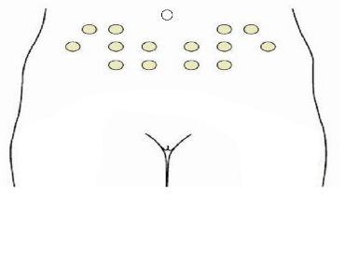

* Select a different site for each injection.
* Clean the site with an alcohol wipe and allow it to dry.
* Do not expel the air bubble from the syringe.
* Lie down on your back and gather a fold of skin with your thumb and forefinger at the site of the injection. This fold of skin must be maintained throughout the injection.

**Gather a fold of skin with your thumb and forefinger for the site of the injection**

* Using your dominant hand, hold the syringe like a pencil between your thumb and middle finger. Insert the needle vertically (at 90º angle to your skin) into the folded skin as far as it will go. Once inserted, the needle should not be moved. Depress the plunger using the forefinger.
* When you have injected all the contents of the syringe, remove the needle and press down lightly with the alcohol wipe. Do not rub the site.
* Safely dispose of your needle as instructed in the hospital.

**Tips and timesavers**

You should always carry a spare appliance with you in case of leakage and to any appointments related to your surgery.

You should bring your ostomy supplies when you come to the hospital. If you forget, the hospital can provide you with one. The ostomy appliance you are provided with may be different than what you are used to.

When you travel, you should have enough supplies with you to last the entire trip.

1. Carry a letter from your doctor stating that you have an ileal conduit/urostomy and need supplies.
2. Make a complete list of all the supplies you need.
3. Take twice as many appliances as you might expect to use, as supplies may be difficult to get at your destination. Include a supply of baggies and/or plastic bags for disposal purposes.
4. If possible, obtain a list of suppliers along your route.
5. If you are traveling by car, store your supplies in a cool area as heat may affect the seal. If you are traveling by bus, train or plane, store your supplies in your carryon bag. Remember that scissors will need to be left in the stored luggage if you travel by plane. You can precut a couple appliances to take with you on the plane since scissors are prohibited.
6. If traveling by plane, empty your pouch before departure and an hour prior to arrival, in case of delays at customs, etc.
7. If camping or backpacking, store your supplies in a waterproof container.

## When should I call my community NSWOC?

1. If you notice a cut in your stoma that continues to bleed.
2. If you notice ongoing bleeding at the junction between the base of the stoma and the skin.
3. If you notice a change in the stoma colour from red/pink to black.
4. If you notice any skin irritation or ulcers that do not get better.
5. If you are changing your flange greater than 2 times per week or are having frequent leaks.

**Call your doctor or go to the nearest Emergency Department if you have any of the following**

* Elevated temperature greater than 38.0°C/ 100.4°F and/or chills lasting more than 24 hours.
* Increased discomfort, redness, swelling, drainage or separation of the incision.
* Nausea, vomiting, diarrhea, abdominal swelling.
* Chest pain or difficulty breathing.
* You experience severe pain that is not relieved by pain medication.
* You have back or side pain.
* Your urine has changed colour looks cloudy, looks bloody, or has large blood clots in it and it has a foul odour. The presence of mucus is expected.
* New or unexplained symptoms
* Not making urine in 6-8 hours

**Follow-up appointments**

Before leaving the hospital, plan the following appointments:

■ Your surgeon: ________________________________________________

Expect to return to hospital to see your urologist in two to four weeks. If you are unable to keep your appointment, please telephone in advance.

**Contact information**

*Your urologist’s name:*

Dr.

■ Have your clips removed from your surgical incision (your surgeon will tell you before you go home where and when this will occur):

____________________________________________________________

■ Make an appointment with your family doctor to review your general health.

Reference

The Ottawa Hospital, Clinical Pathway Project Team. © The Ottawa Hospital, August 2017.