SURGICAL SERVICES

Supplies needed after your abdominoperineal resection (APR)

Seating Cushion
After your surgery, you will be required to use a special seating cushion to reduce pressure over the incision while you are sitting.

The seating cushion is to be purchased before surgery, labelled with your first and last name, and brought to the hospital when you have your surgery.

Avoid donut-shaped cushions as they may injure your incision.

Below are examples of foam seating cushions UNDER $100. Other brands are also available. Prices may be subject to change depending on the vendor.

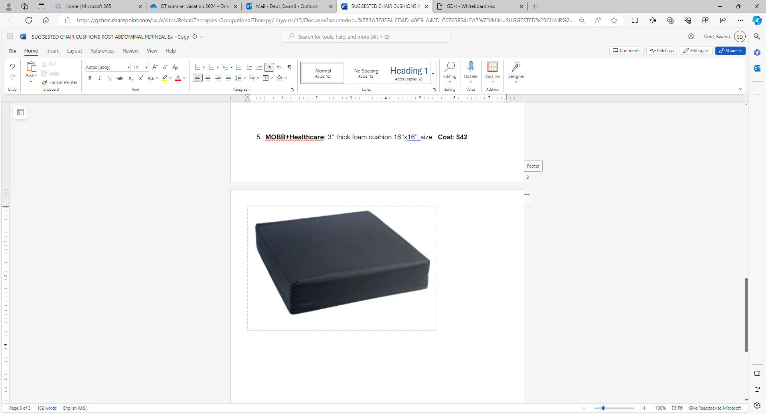 | MOBB+Healthcare  Size: 16” x 16” x 3”
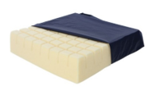 | AliMed Independent Cell Cushion  Size: 18”x16”x4”
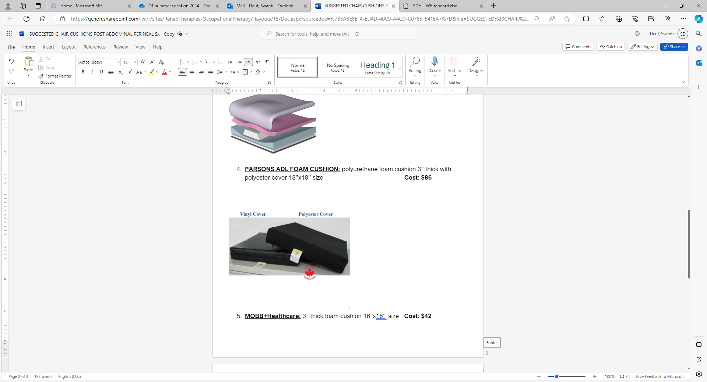 | PARSONS ADL FOAM CUSHION  Size: 18” x 18” x 3” with a vinyl or polyester cover

CONTINUED ON OTHER SIDE
Information is available in alternative formats upon request.
Urinal (also called urine bottle)
If you sit down to urinate, a urinal is required. Sitting on the toilet is harmful to your new incision.

The urinal is to be purchased before surgery, labelled with your first and last name, and brought to the hospital when you are having your surgery.

It is strongly recommended that you practice using it before your surgery to ensure comfort and ease of use.

Below are examples of two types of urinals available.

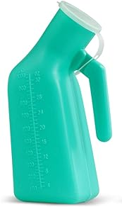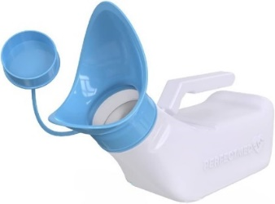 | Anatomy Specific Urinals  These urinals are designed to accommodate various body anatomies.  The key difference is the size of the opening. Urinals with a narrower opening is often referred to as “male urinals”. Whereas the urinals with wider openings are often referred to as “female” or “unisex urinals”. Use the urinal based on your body’s needs.

Seating cushions and urinals are available at a variety of medical supply stores or online such as:
- Ontario Medical Supply (OMS) –613-220-8794
- Wellwise by Shoppers – 613-725-0608
- Conval-Aid – Potential to rent or buy - 613-738-2721
- Canada Care Medical – 613-234-1222
- Amazon.ca

This list is not exhaustive, nor a recommendation of specific brands or suppliers. Availability may vary by store.

